Force Transducer Guide

Vincent Chen, Eric Otrusina

Sponsored by National Science Foundation



This is a guide to follow to build the force transducer developed by Vincent Chen.

Italics denotes a 3D printed piece. Keep carriages on rails.

Tools required:

* Drill and drill bits (5/16in or 11mm)
* 6mm and 8mm tap set
* Some light lubricant
* Metric hex keys
* Calipers (not pictured)

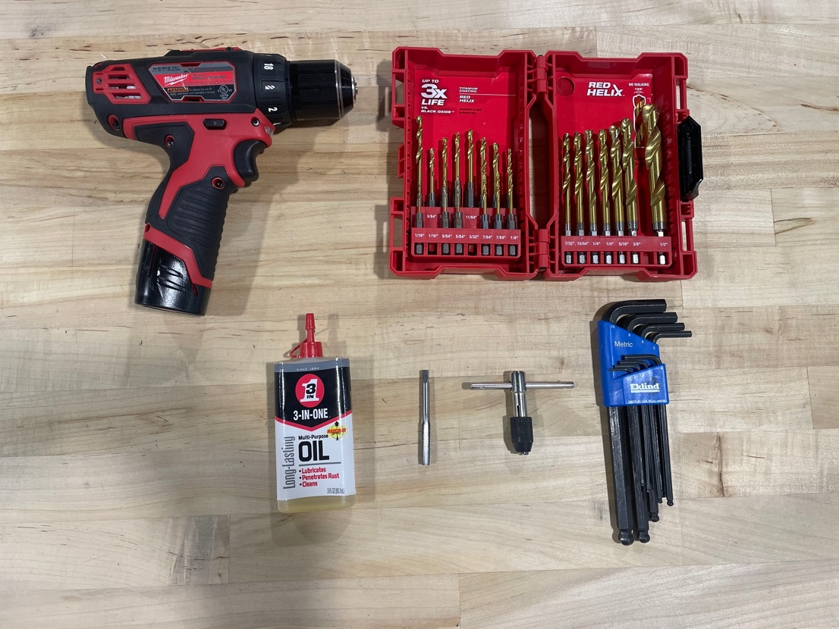

Materials are to be gathered from the BOM. Also, some topics are not covered in depth, as they are outside the scope of this guide. For these topics, there will be referrals to outside resources.

For a guide on blind joints and tapping extrusions, see “Blind Joint Basics” by NERO 3D on YouTube - <https://www.youtube.com/watch?v=2dvbn0rWA60>.

Tap both ends of each 540mm extrusion.

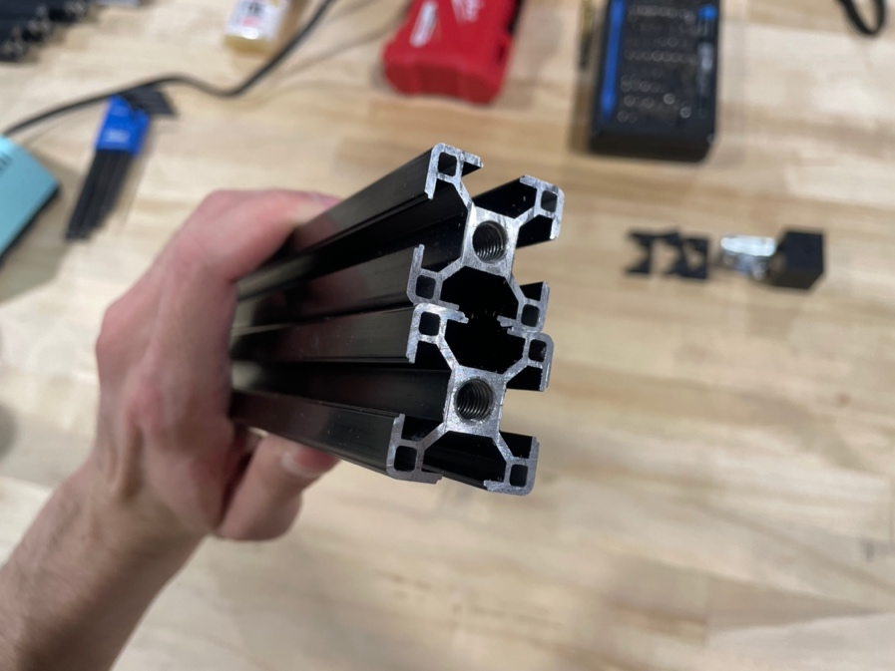

Then, drill a hole through the sides of both extrusions 45mm away from the end to the center of the hole. To do this, use *3030_drill_jig*. To set up the jig, use two M3x10mm bolts with M3 wing nuts. Tighten down the bolts so that the jig doesn’t move while drilling and go all the way through.

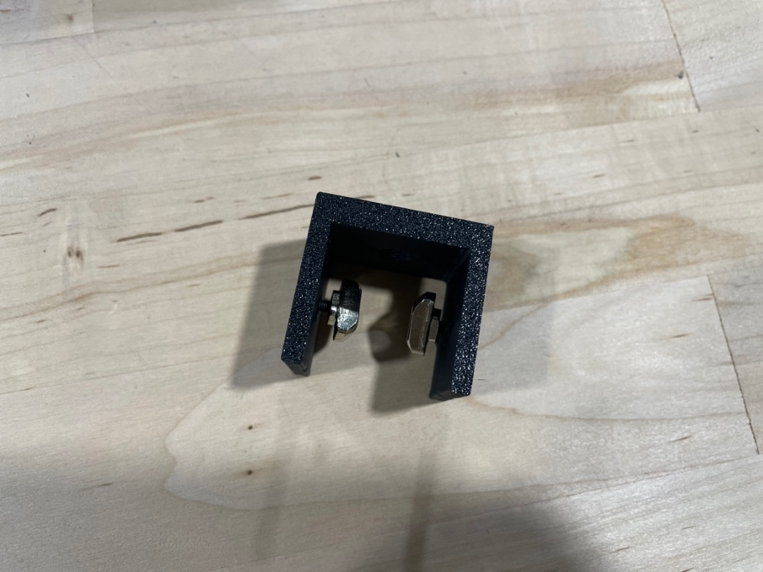

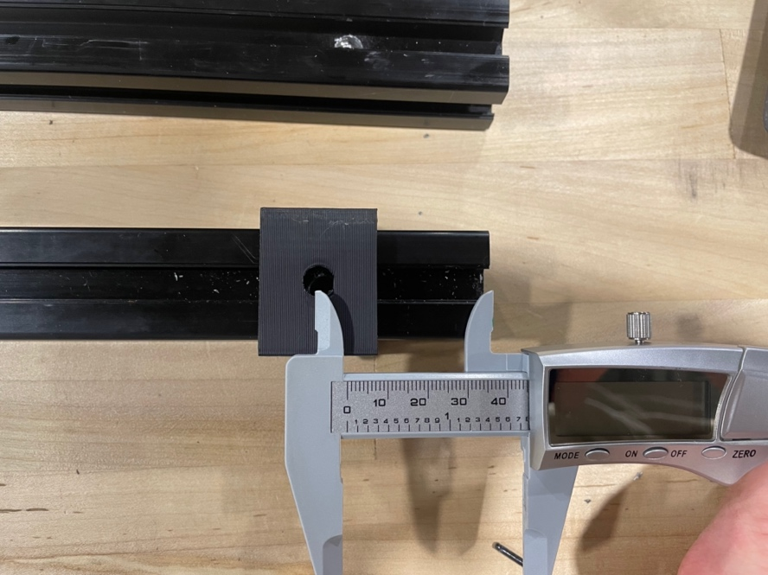

Ta da! The 540mm extrusions are ready.

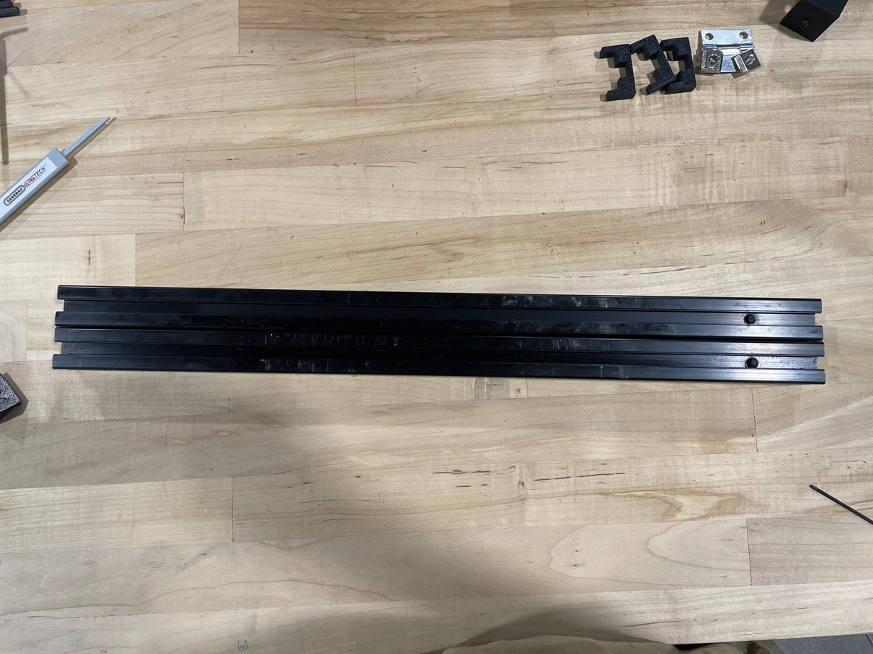

Next, we will prep the four 200mm extrusions. ¾ of them will need holes 15mm away from the edge on both sides. The jig flush with the edge of the extrusion will give the right distance.

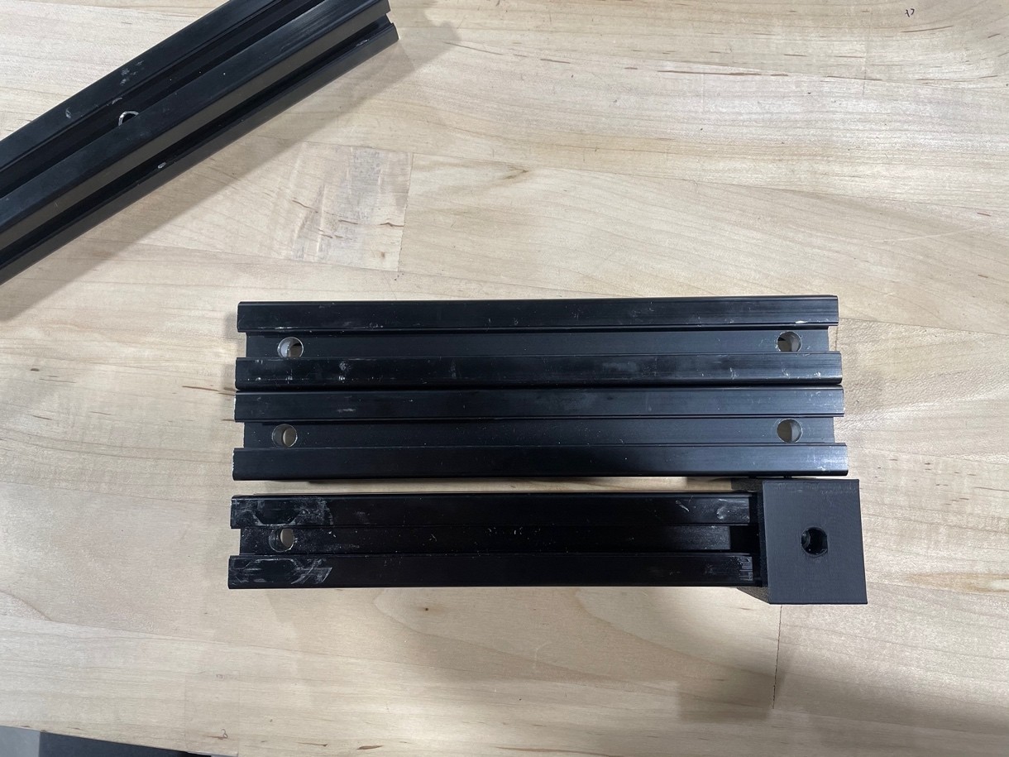

On 1/3 of the extrusions drilled, both ends will need to be tapped.

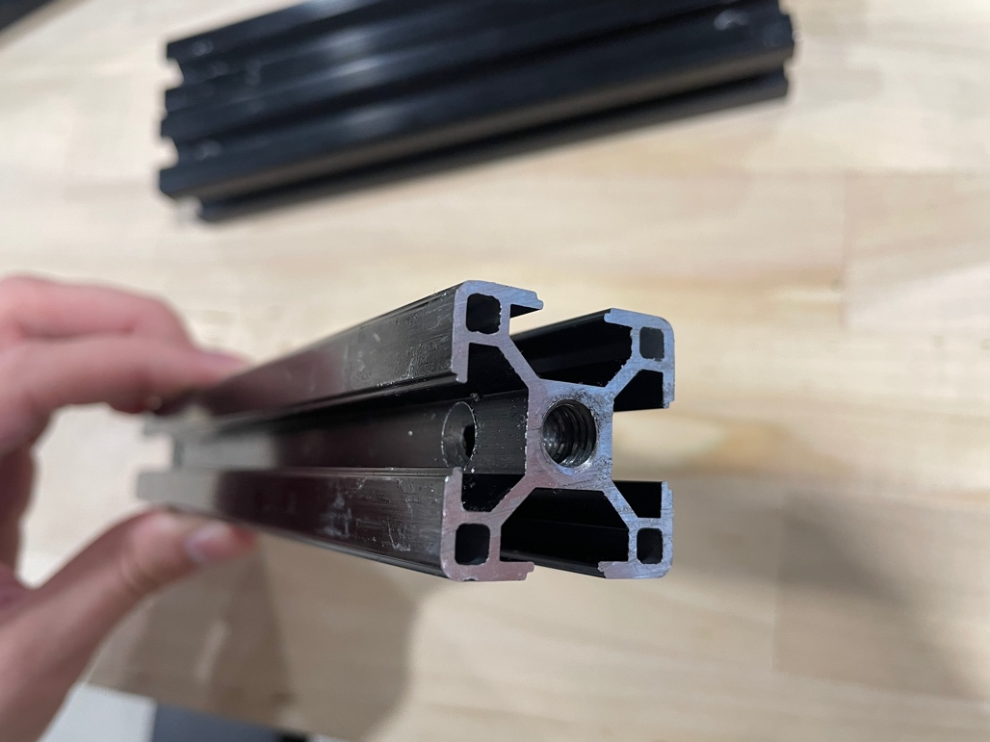

On the remaining 200mm extrusion, two holes will have to be drilled in the middle so that no matter how it’s viewed there’s a hole in the center.

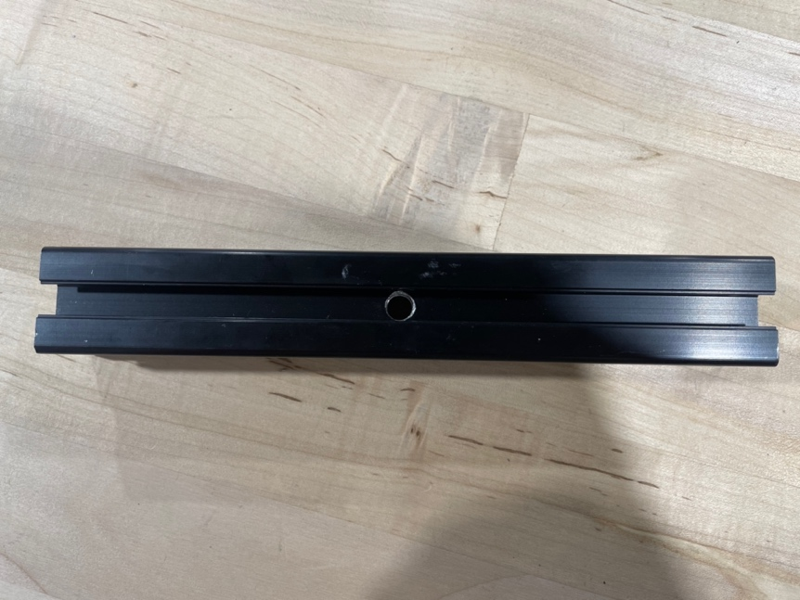

The 200mm extrusions are set!

To put together the first rectangle we will need:

* Four M6x10mm hex bolts
* Four *thumb_screw*
* Four M6 T-nuts
* Four M8x16mm socket cap screws
* Two 3030 T-plates
* Two 540mm extrusions
* One 200mm extrusion with edge holes
* One 200mm extrusion with edge holes and tapped ends

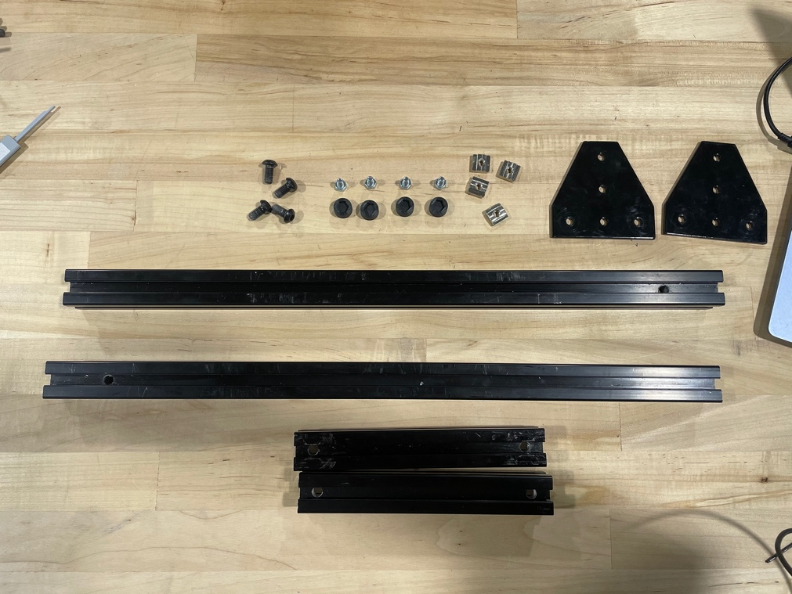

Push the hex bolts into the *thumb_screw* prints.

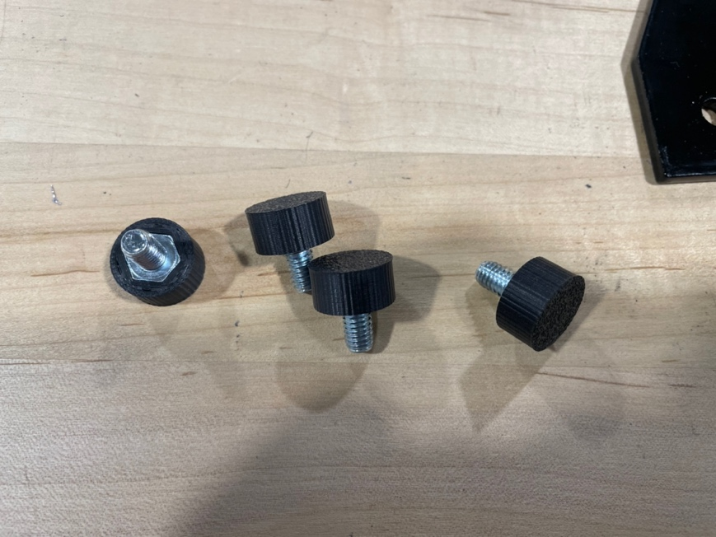

Slide two M6 T-nuts into opposing sides of the 540mm extrusions.

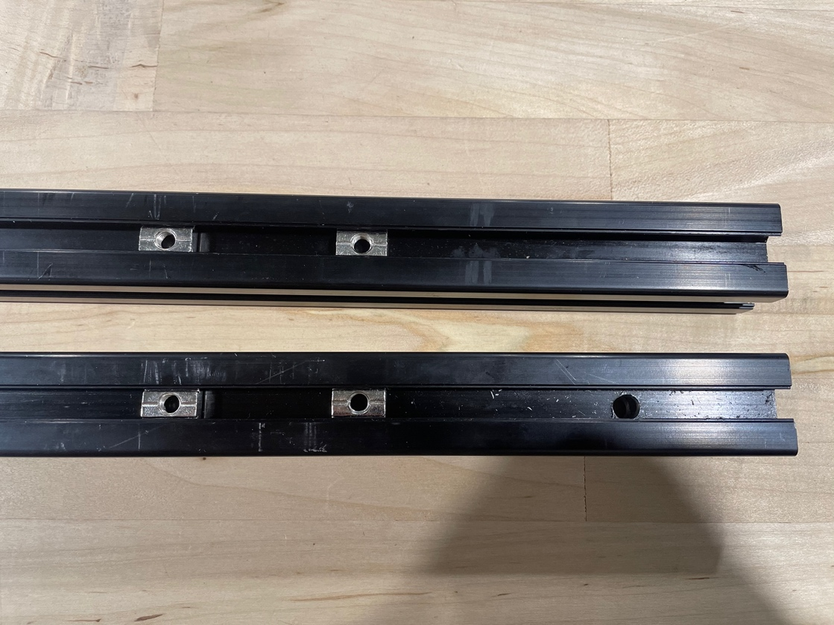

Screw the T-plates onto the extrusions but leave them loose so that they can slide around.

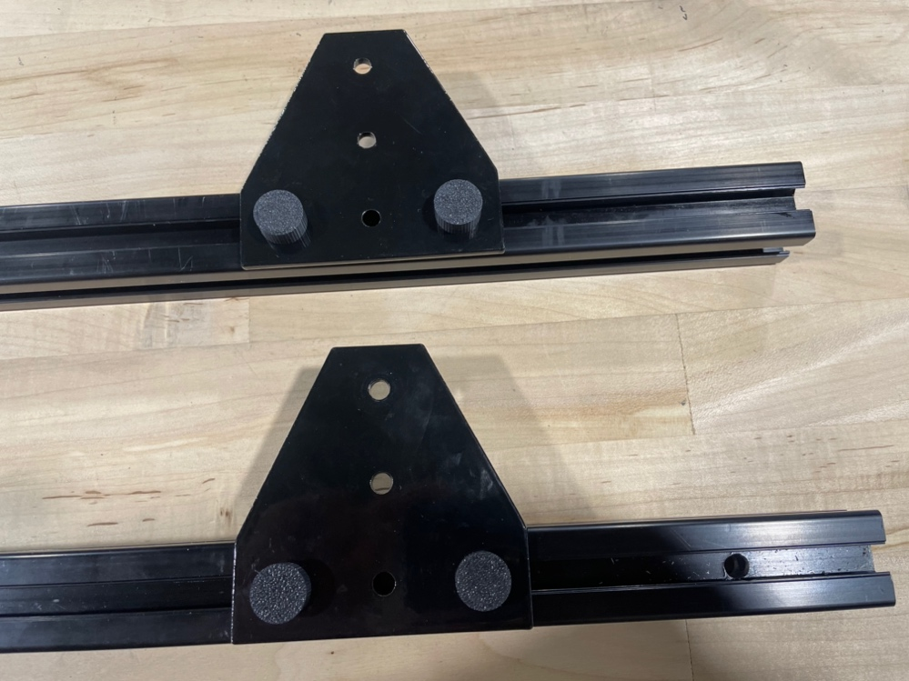

Thread two M8x16mm socket cap screws into the ends of the 540mm extrusions near the drilled holes.

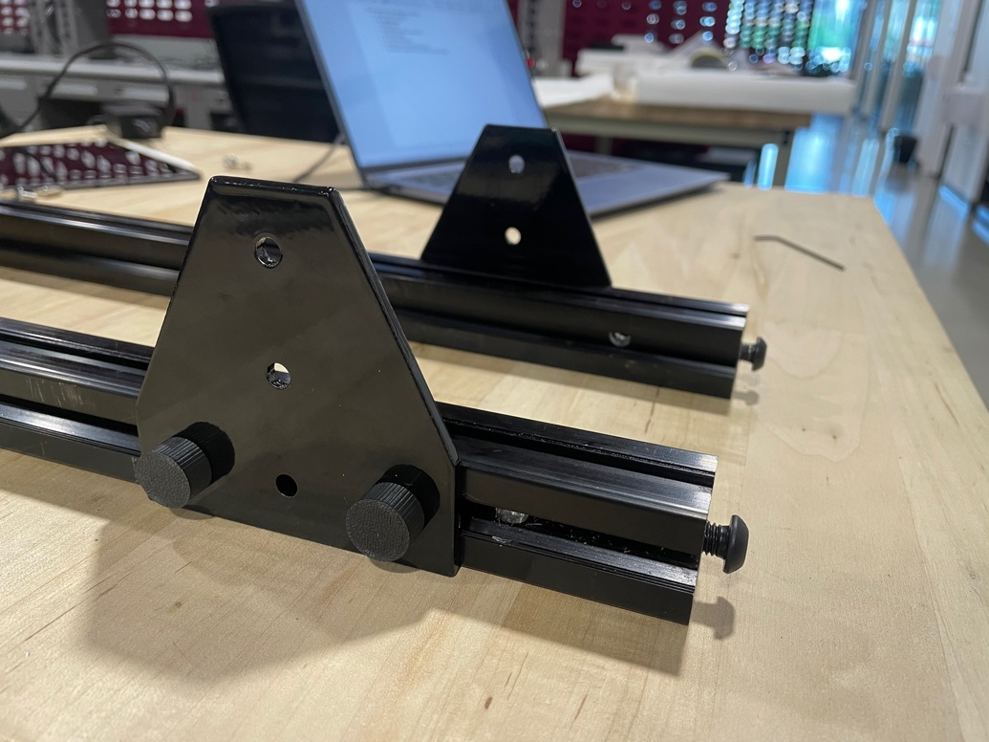

Slide the 200mm extrusion **without tapped holes** into place for a blind joint, making sure that everything is tightened square.

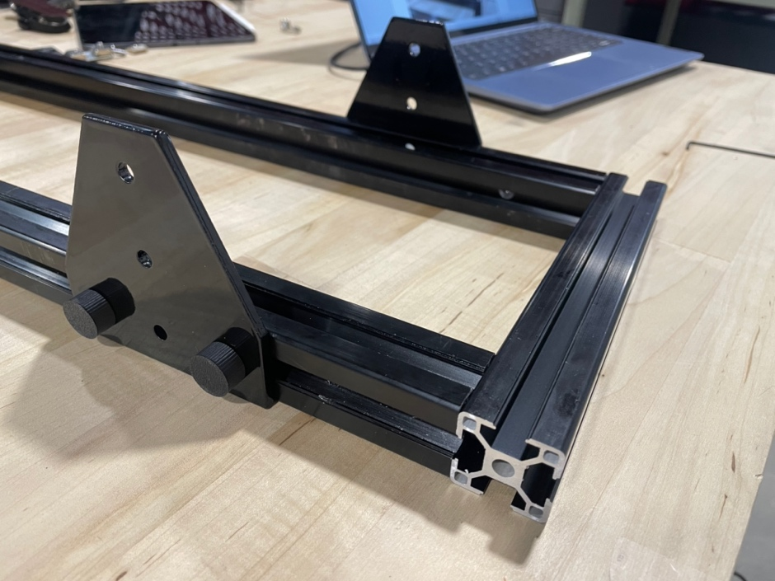

Do the same for the other end using the 200mm extrusion with **tapped ends**.

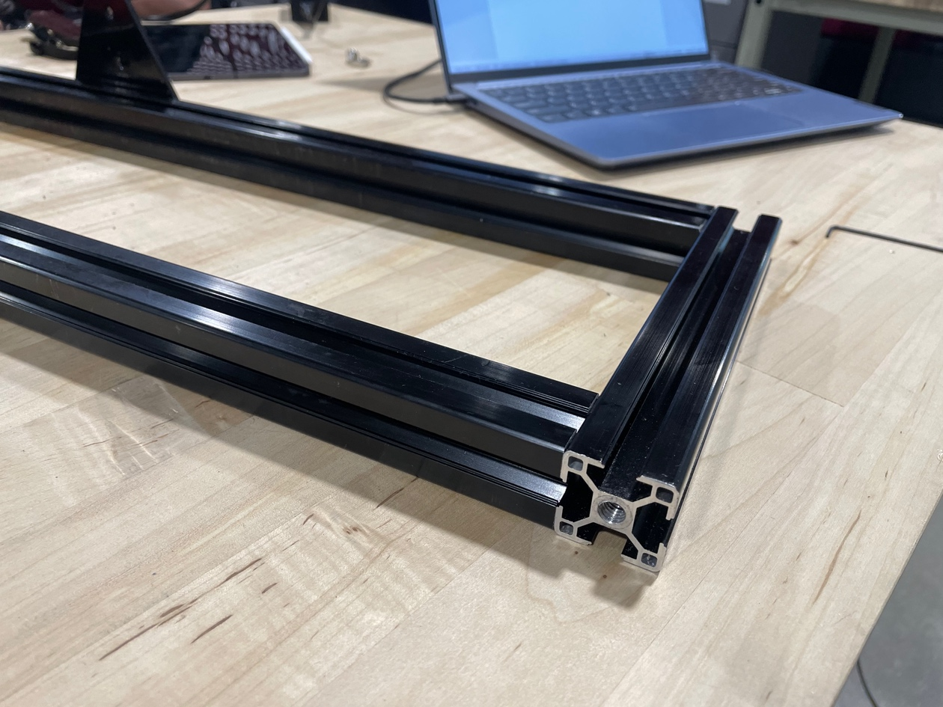

You should be left with something like this:

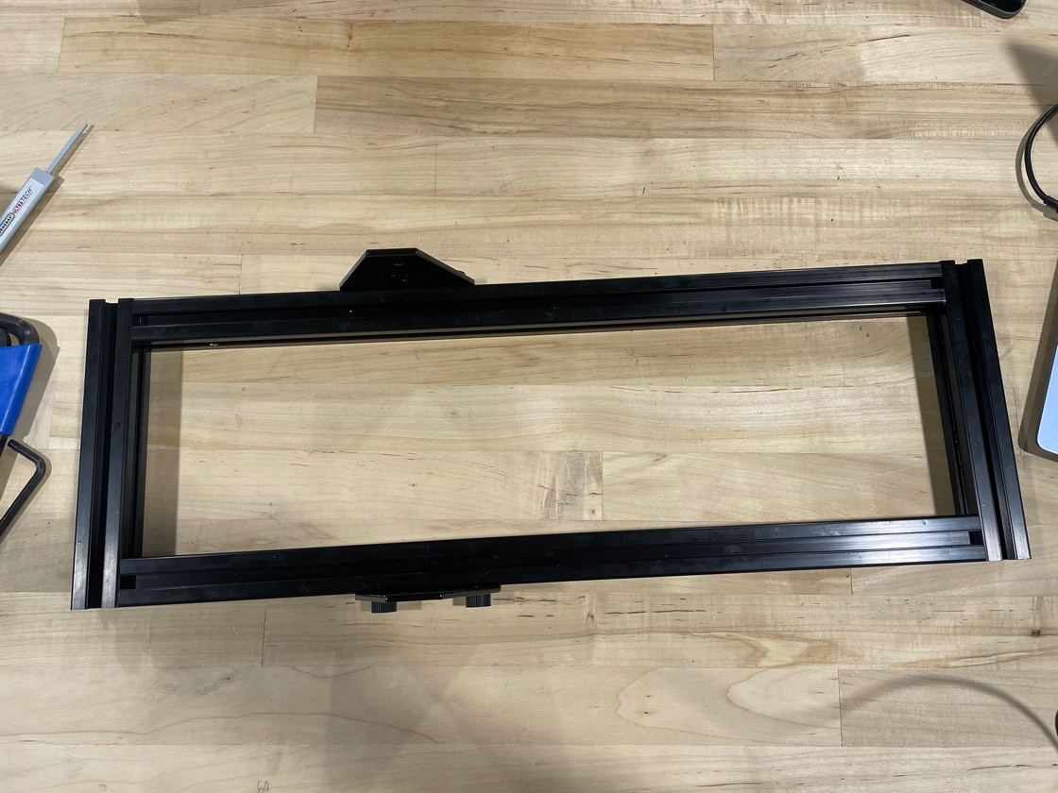

Slide two M6 T-nuts into the 2020 extrusion with **tapped ends**.

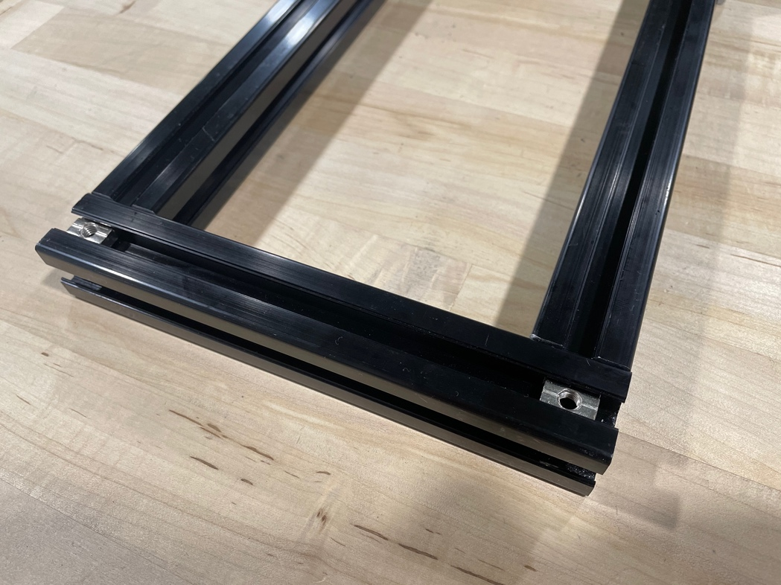

Using two M6x12mm bolts, screw in two *rail_stop*.

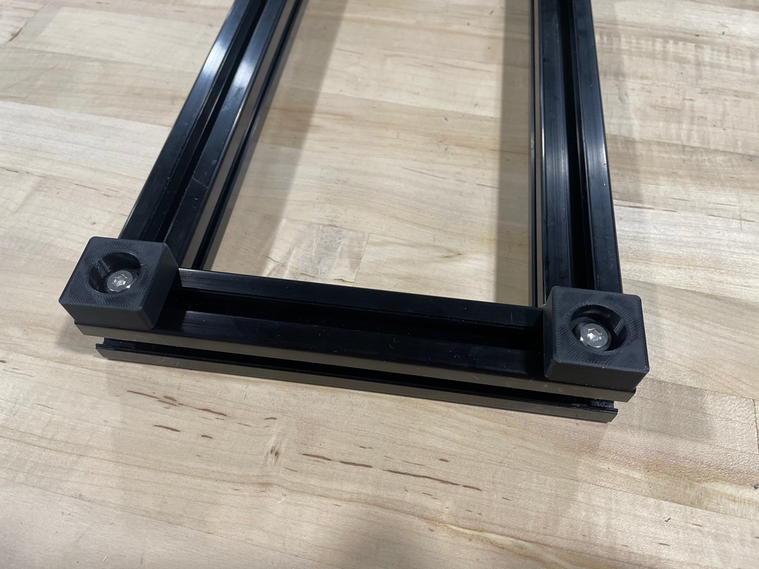

Prep each 500mm MGN12H rail with M3x8mm socket cap screws and M3 T-nuts every three holes or so. Add extra carriages to each so that one rail has two carriages.

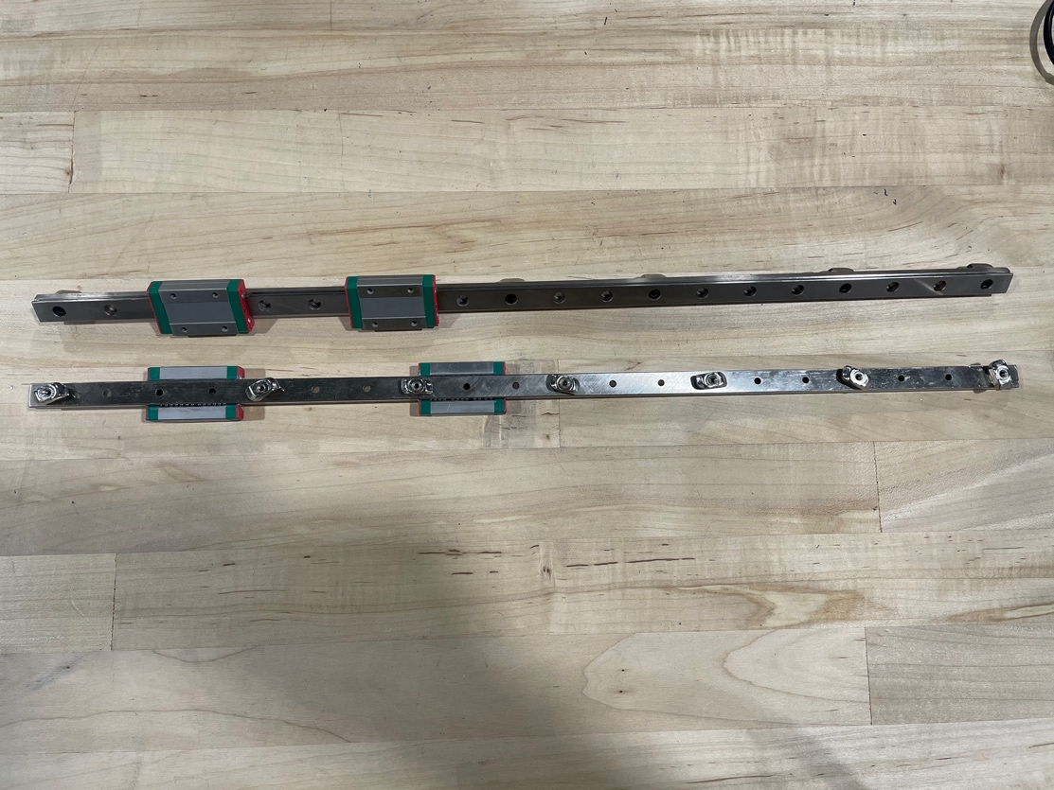

Place one rail onto the extrusion, sliding it up against *rail_stop*. Center the rail using *3030_MGN12_alignment*. Screw the rail down from the center outward.

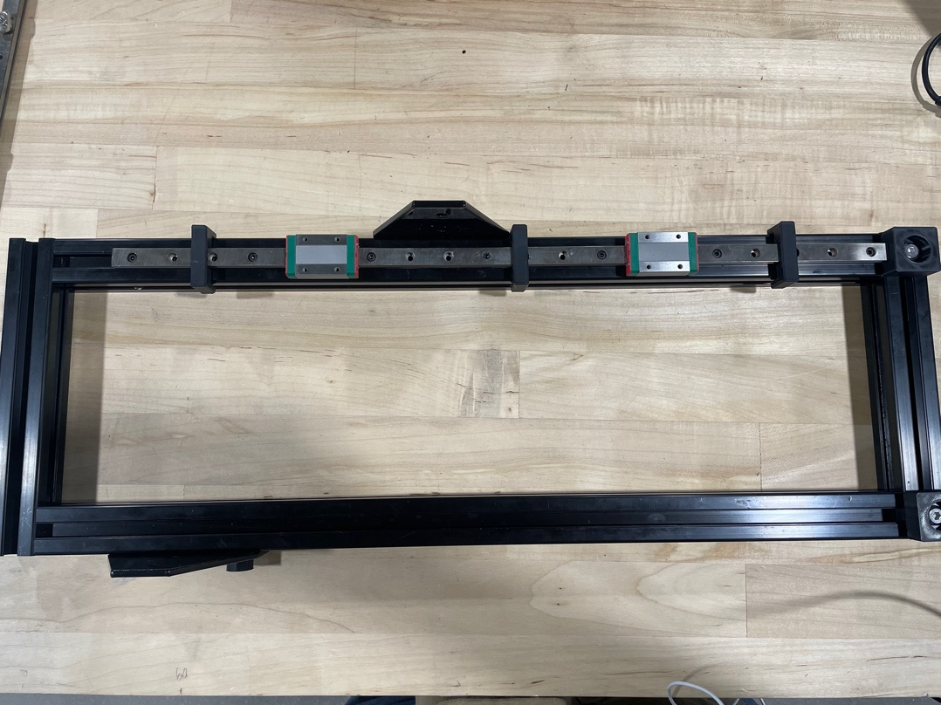

Do the same for the other rail.

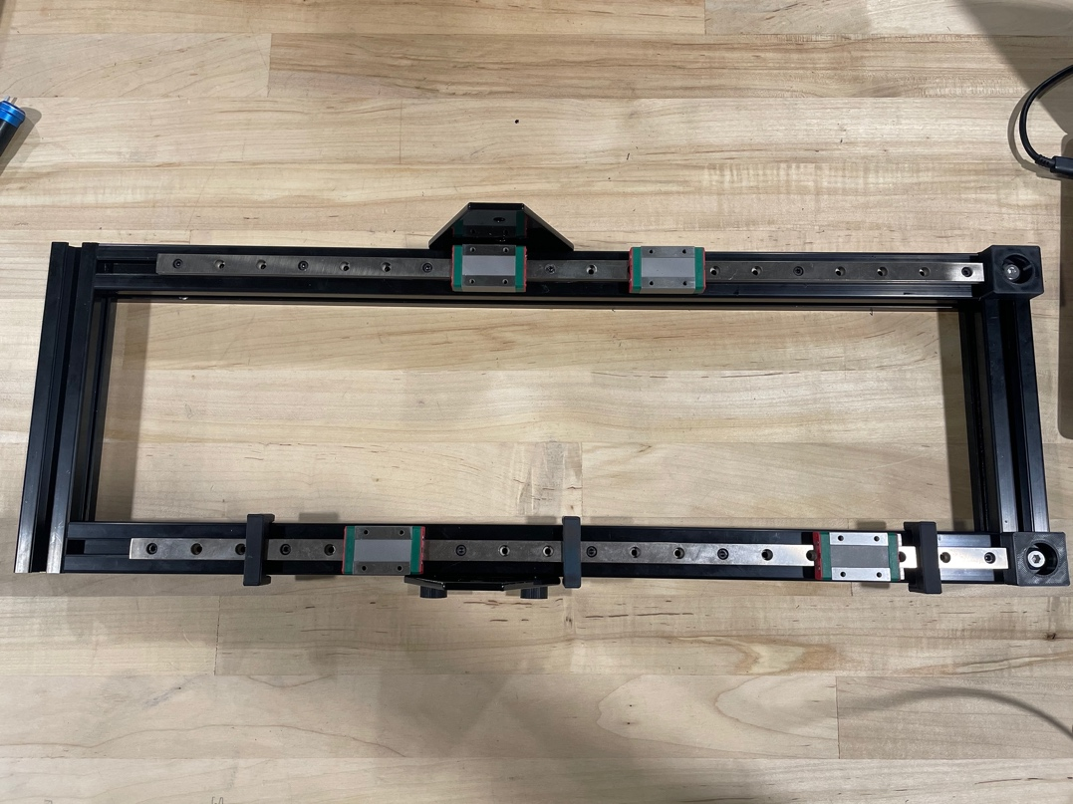

Grab both *main­_carriage* and lightly thread an M6x12mm bolt with an M6 T-nut into each.

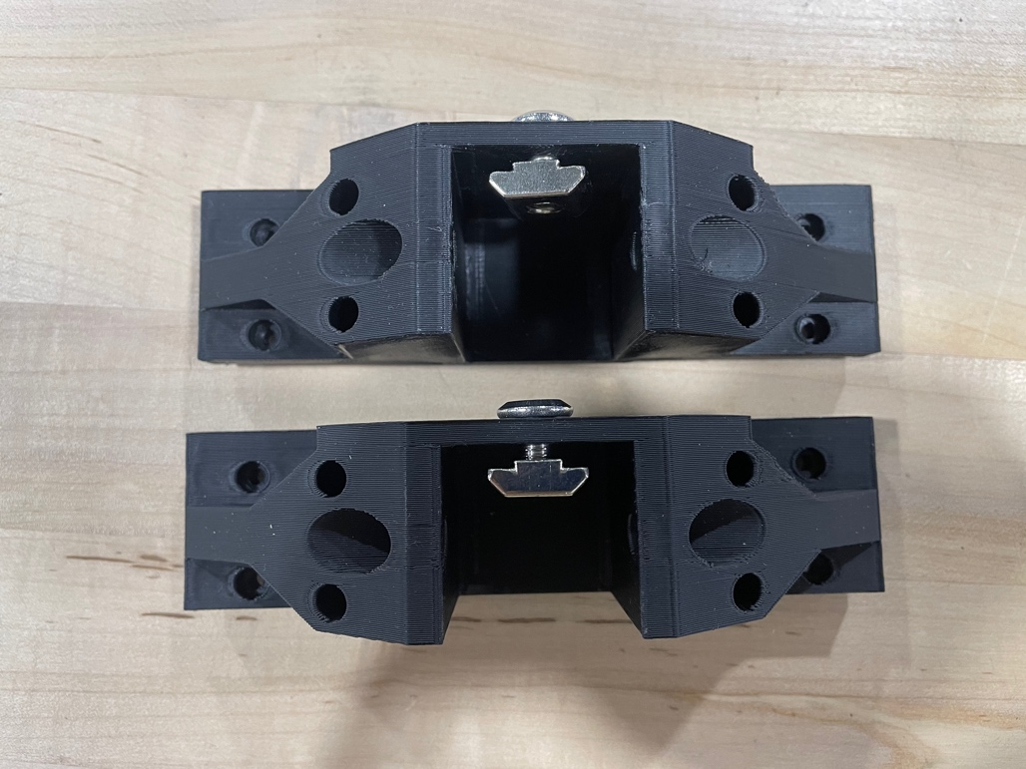

Using sixteen M3x8mm socket cap screws, screw one carriage on each rail.

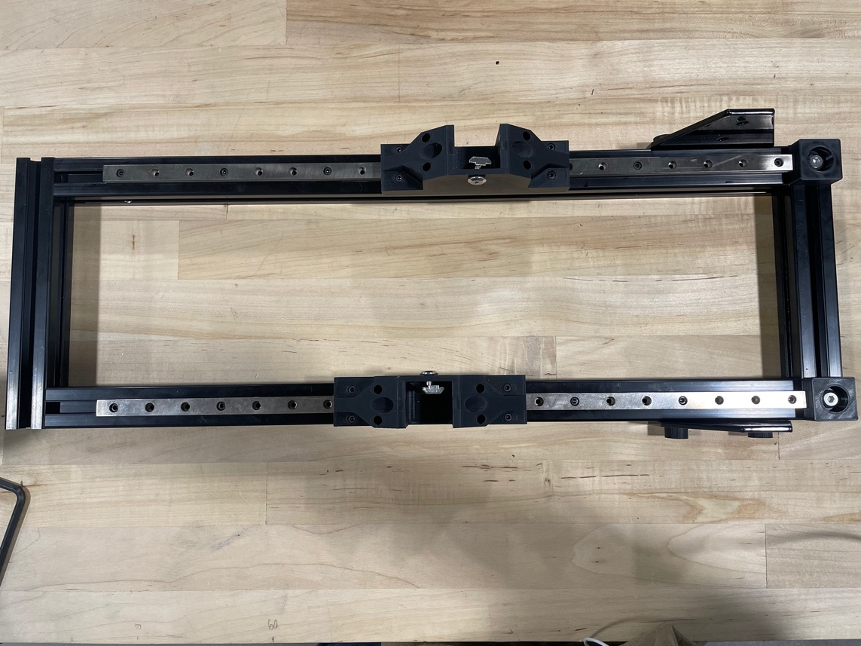

Next, take both 355m extrusions, tapping one end on each.

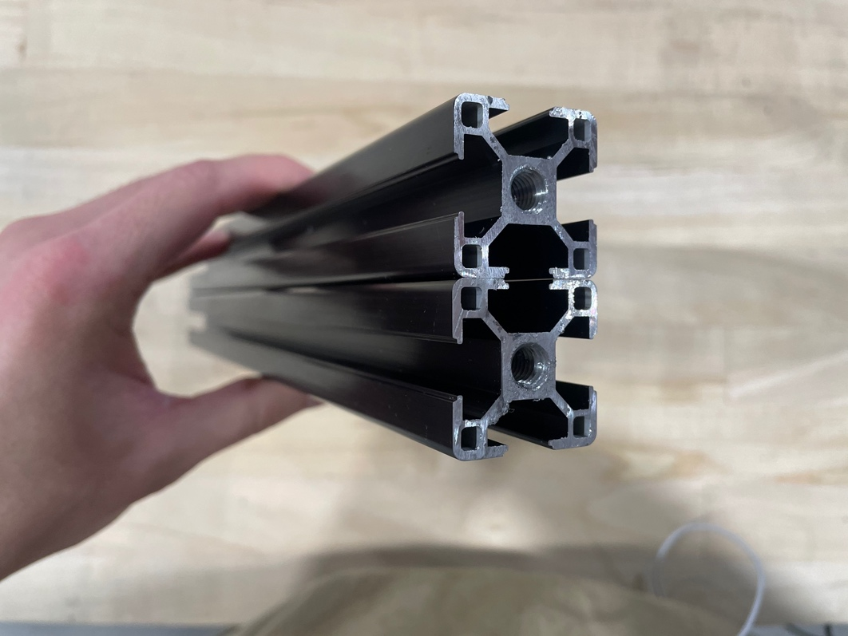

Push the 355mm extrusions into *main_carriage* with the tapped ends facing upward. Tighten the M6x12mm screws.

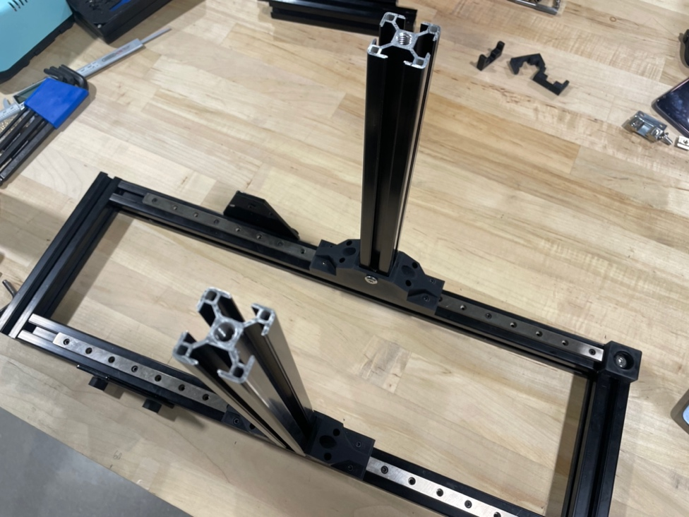

Slide an M6 T-nut into the 355mm extrusion.

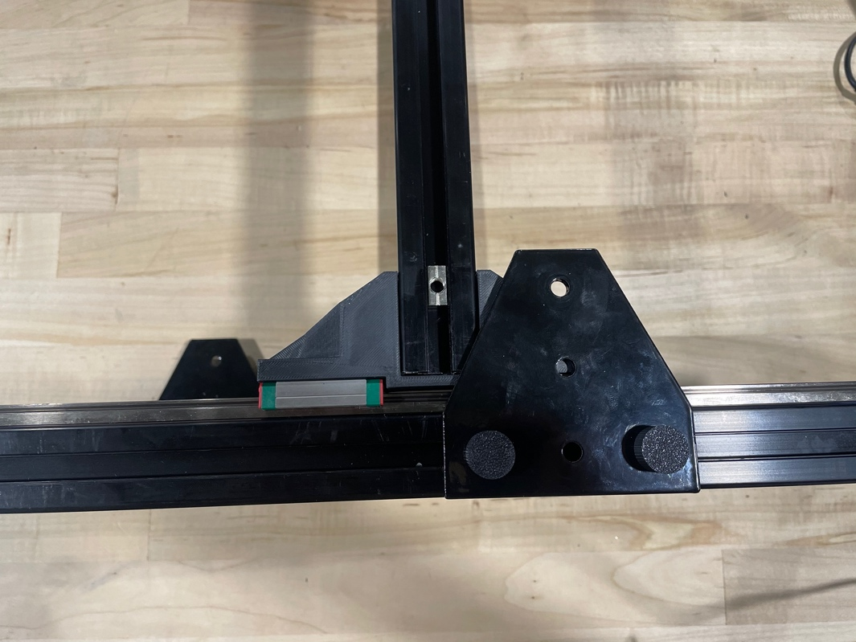

Tighten the T-plate down using an M6x12mm screw. Make sure the carriage can slide around afterward. You may have to loosen the thumb screws a little.

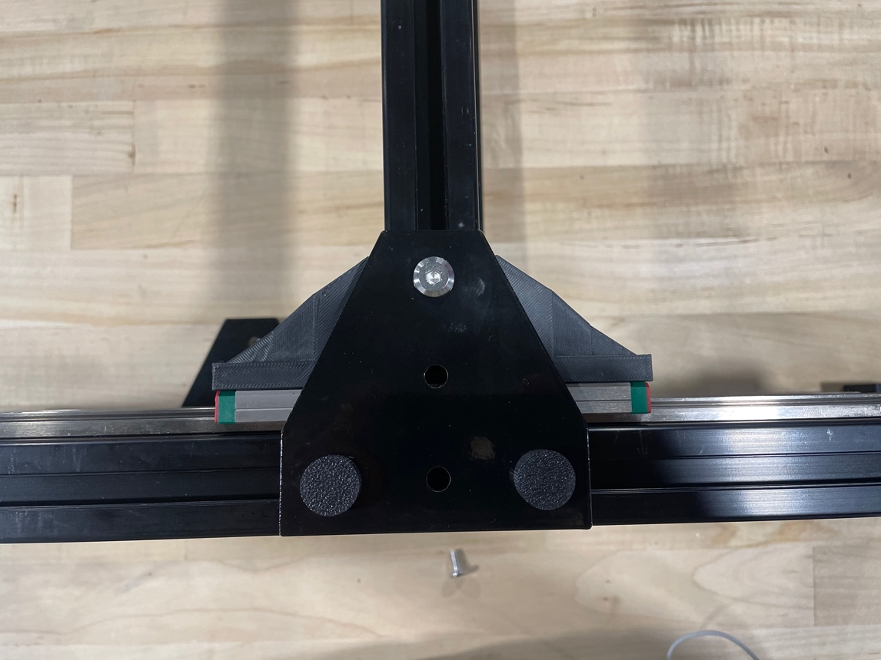

Do the same for the other carriage.

Prepare the 260mm MGN12H rails similarly to the 500mm ones. They will be attached in the same way on the 355mm extrusions toward the side without *rail­­_stop*.

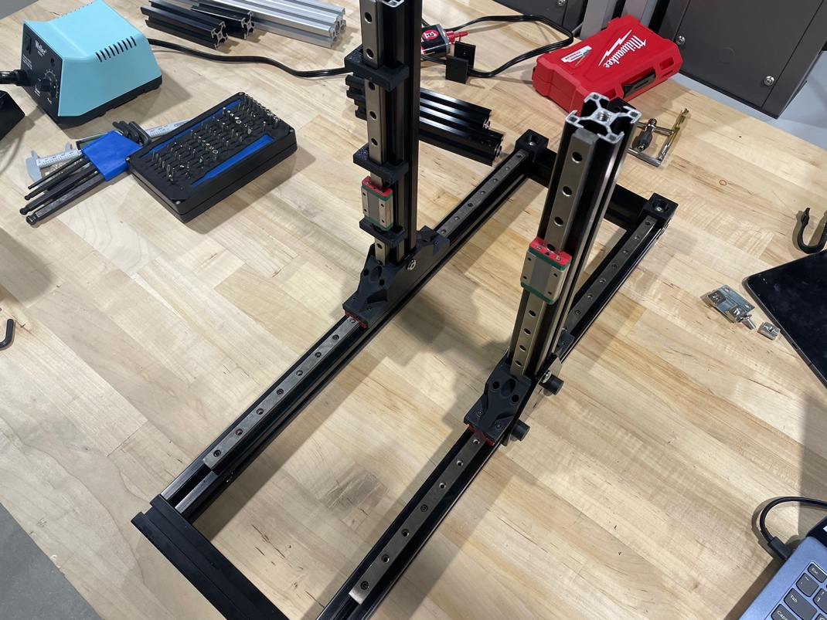

Slide an M6 T-nut into the side of the 355mm extrusion. Loosely a *top_carriage* with another M6x10mm hex bolt and *thumb_*screw. Do the same for the other side.

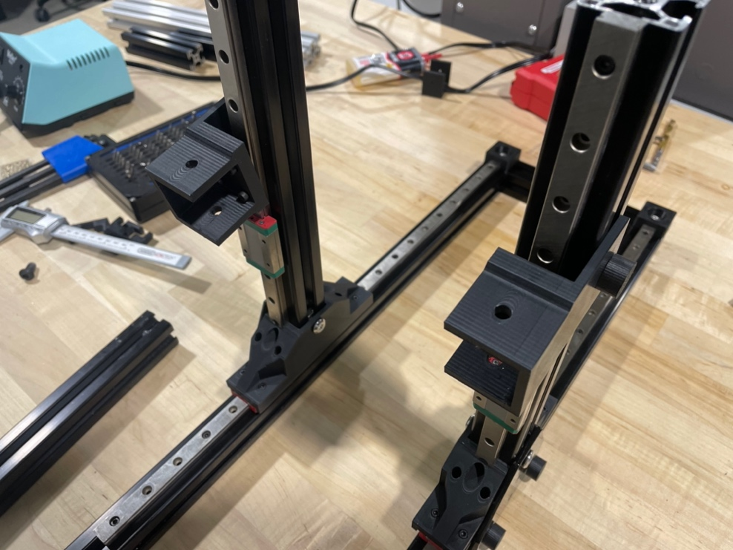

Secure each *top_carriage* to an MGN12H carriage using four M3x8mm socket cap screws each.

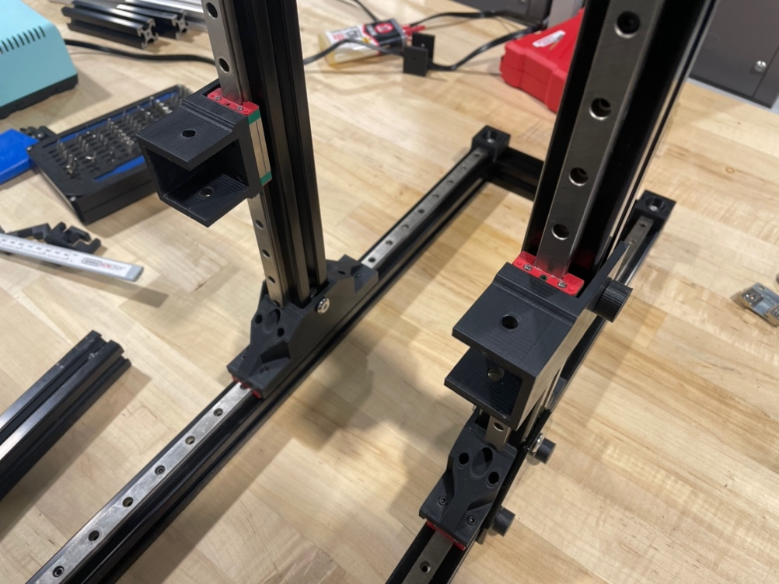

Using two more M8x16mm socket cap screws, attach another 200mm extrusion to the top with a blind joint. Ensure after attaching the top bar that the whole assembly can slide freely. You may have to loosen the screws on the inside of each *main_carriage*, do the blind joints, then retighten to get the carriage moving.

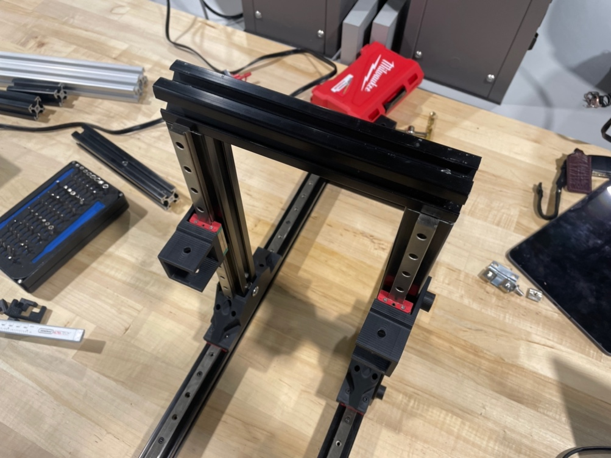

Into the last 200mm extrusion with holes drilled in the middle, slide two M8x16mm socket cap screws and four M6 T-nuts in as shown. The T-nuts are on opposite sides, the screws adjacent.

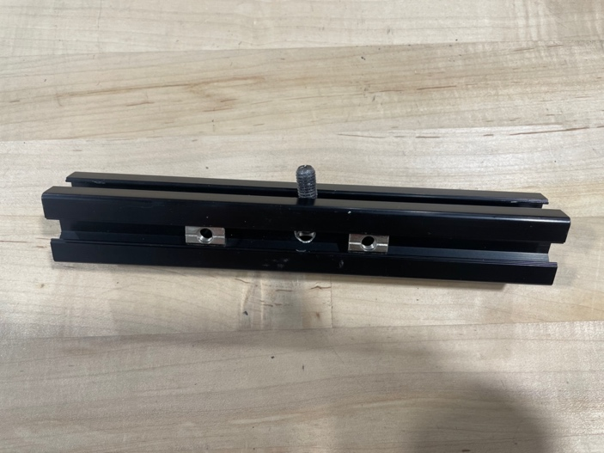 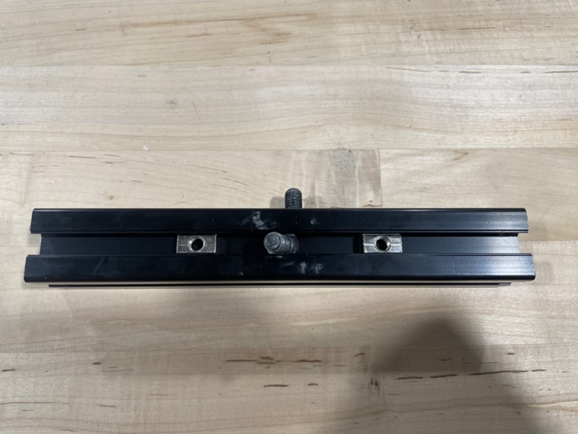

Slide the extrusion into the *top_carriage* as shown.

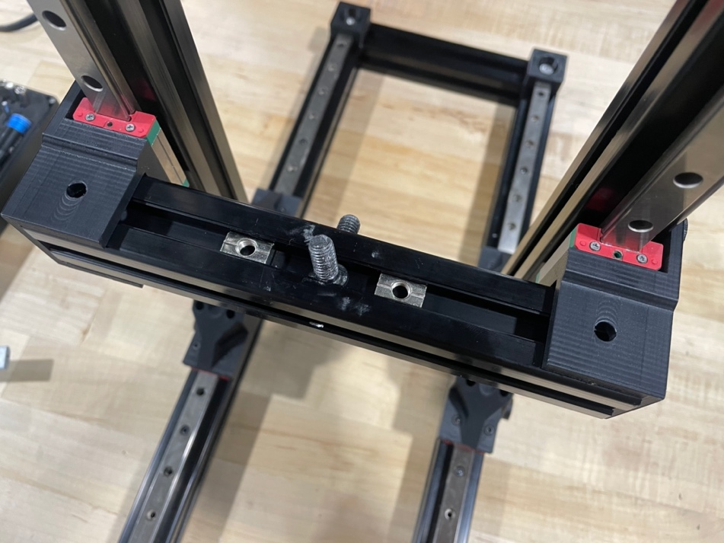

Use a hex key or other tool to nudge the T-nuts into place.

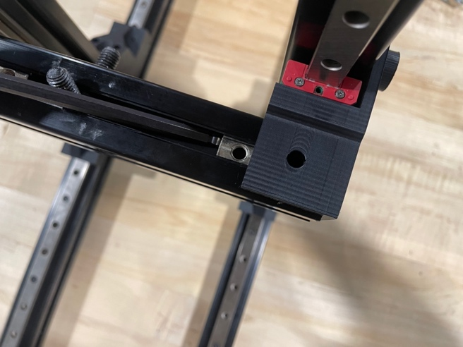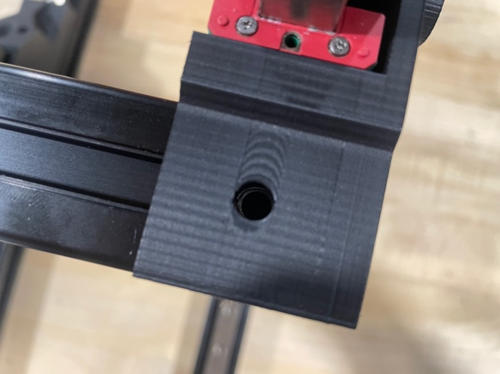

Use M6x12mm screws to secure the extrusion from the four inserted T-nuts. Ensure the carriage can move smoothly up and down.

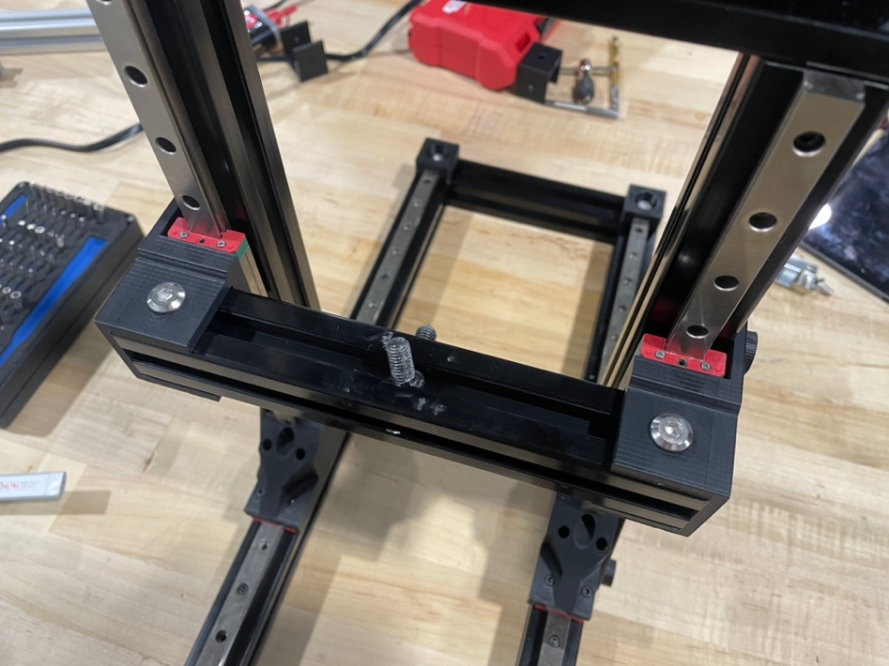

Attach the 80mm and 100mm extrusions as shown.

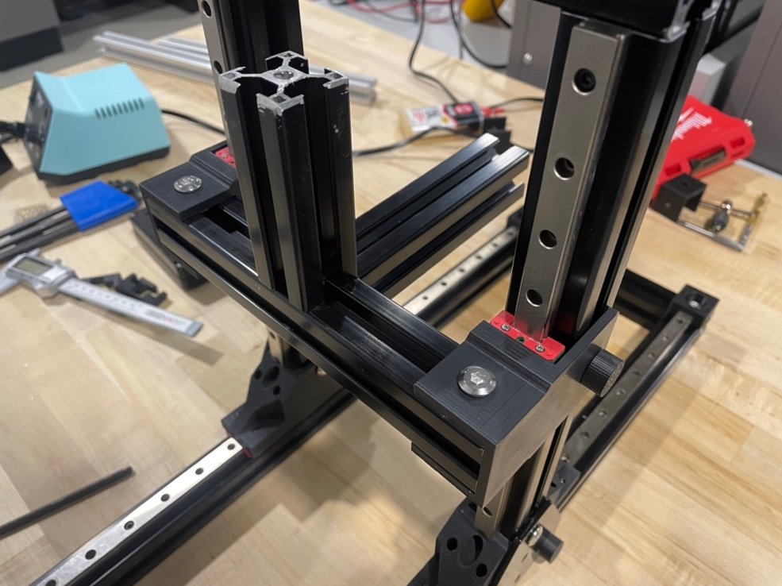

Prepare two *slide_female* with two M3x12mm socket cap screws and M3 T-nuts each.

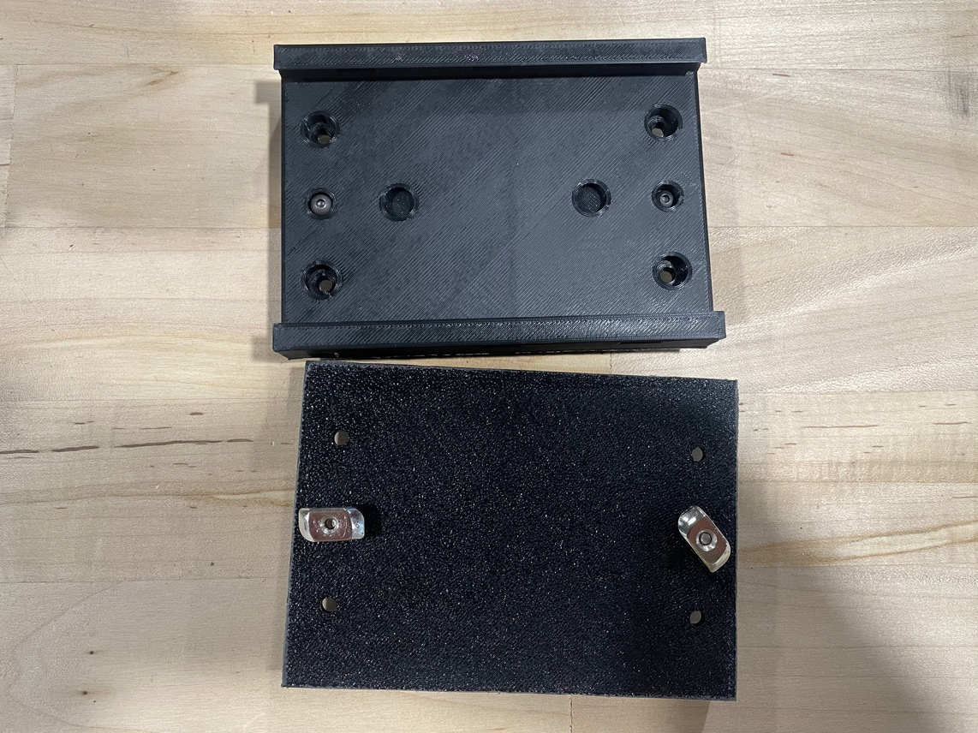

Attach them to the extrusions as shown.

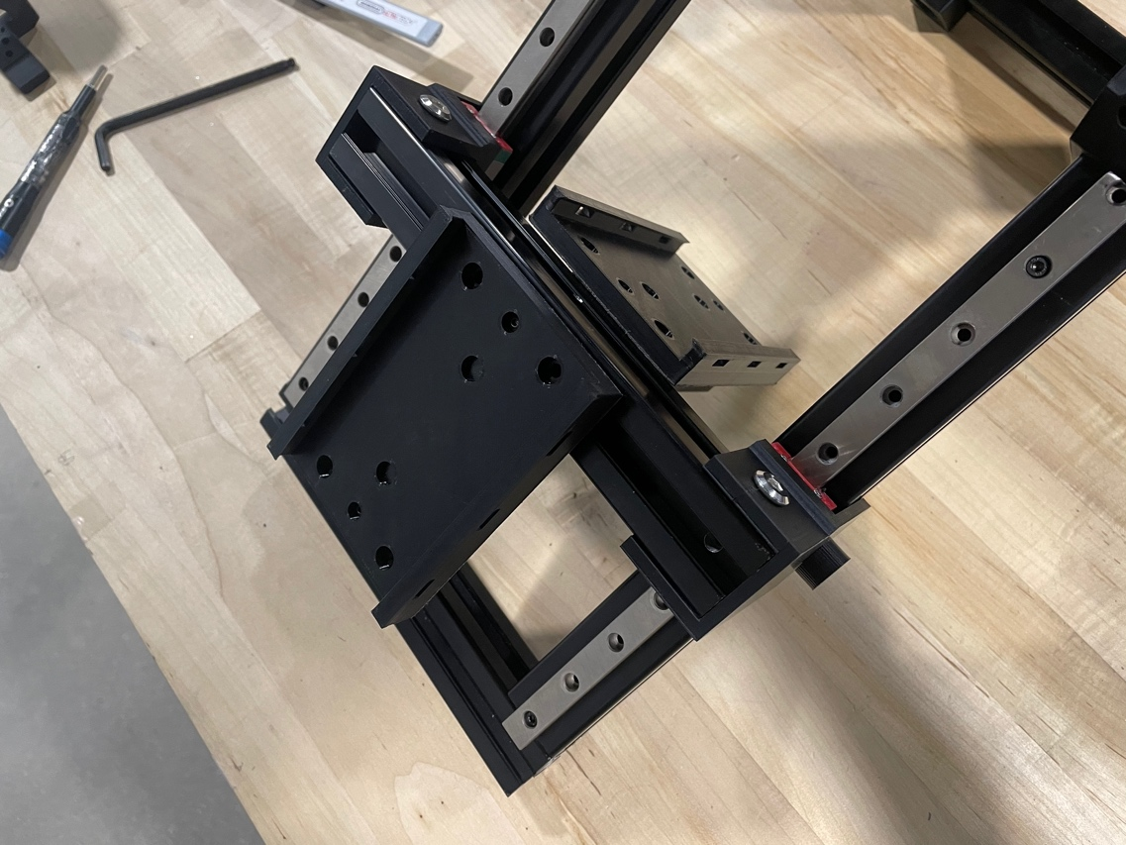

Remove the 200mm extrusion from the front of the printer and slide in an M8x20mm socket cap screw on each side. Add the extrusion back afterward.

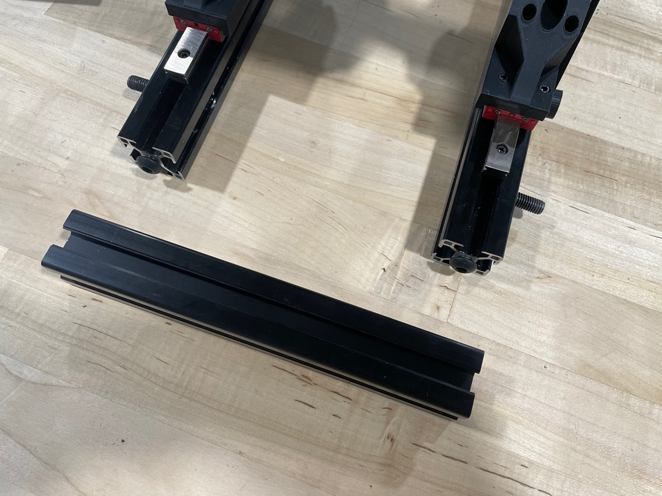

Take four *board_hold* and prepare them with two M3x12mm socket cap screws and two M3 T-nuts each.

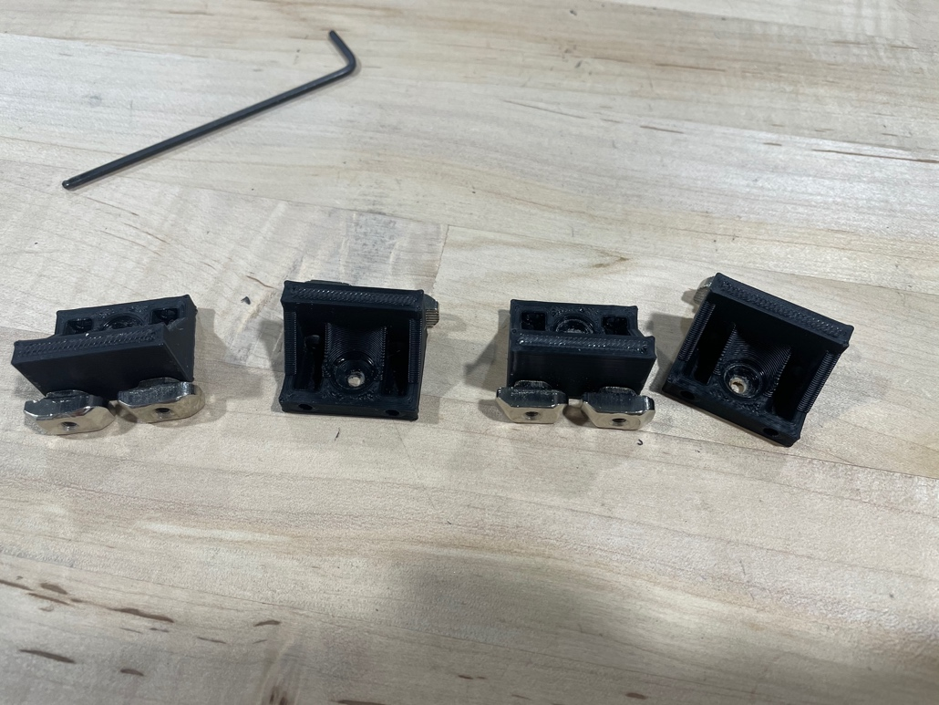

Add *board_hold* to both sides, 100mm from the extrusion.

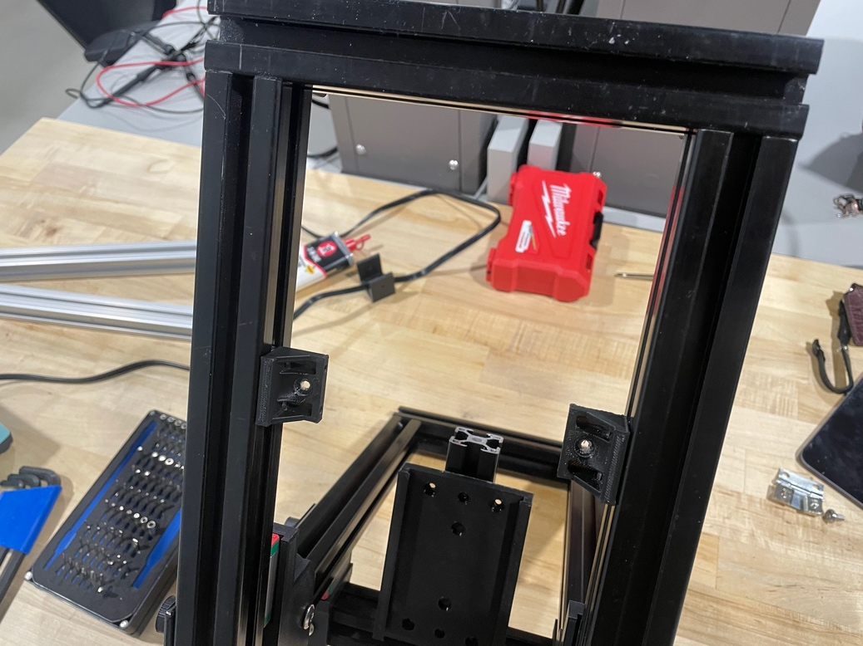

Do the same for the lower part of the assembly.

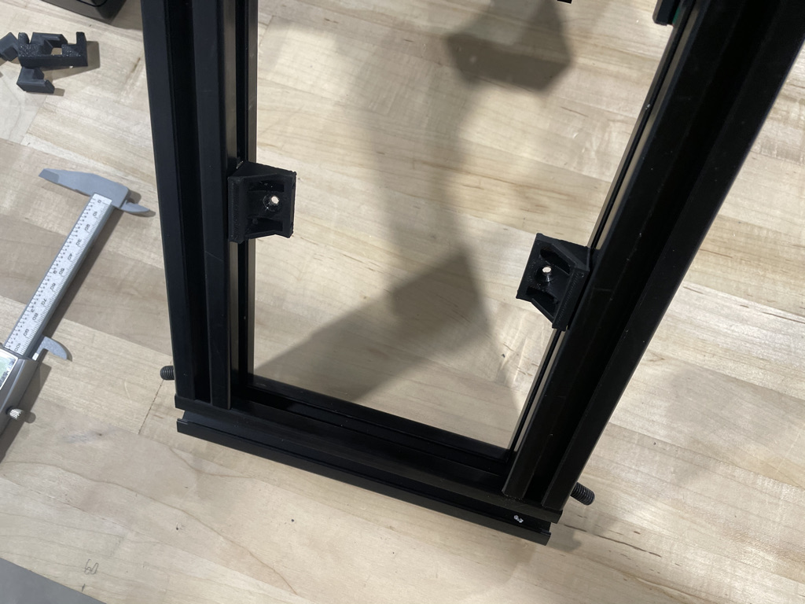

Attach the smaller acrylic sheet with #8x5/8in screws in each holder. You may have to drill a pilot hole to avoid cracking the sheet.

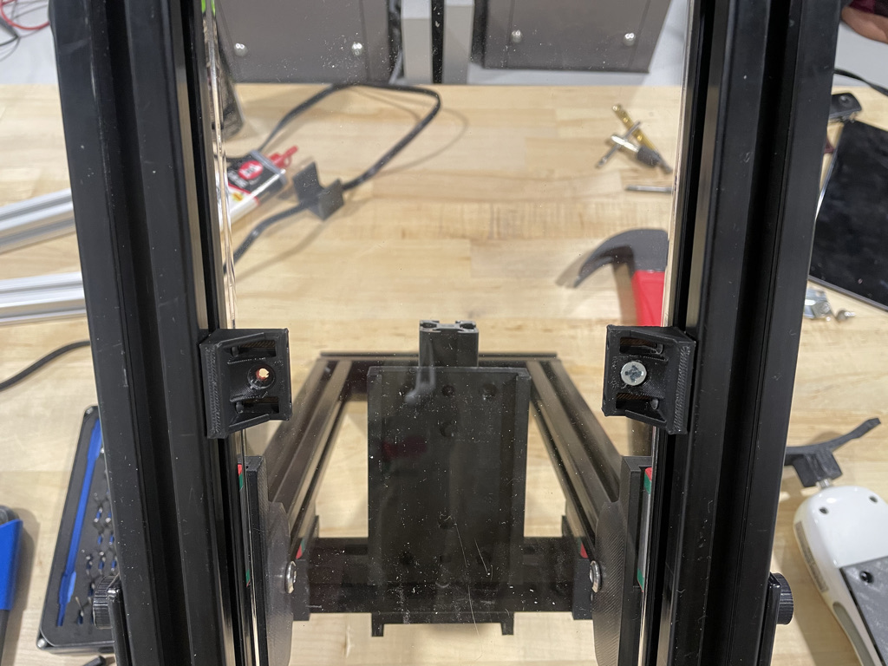

To prepare the hinges, take both and drill one side with the 5/16in bit.

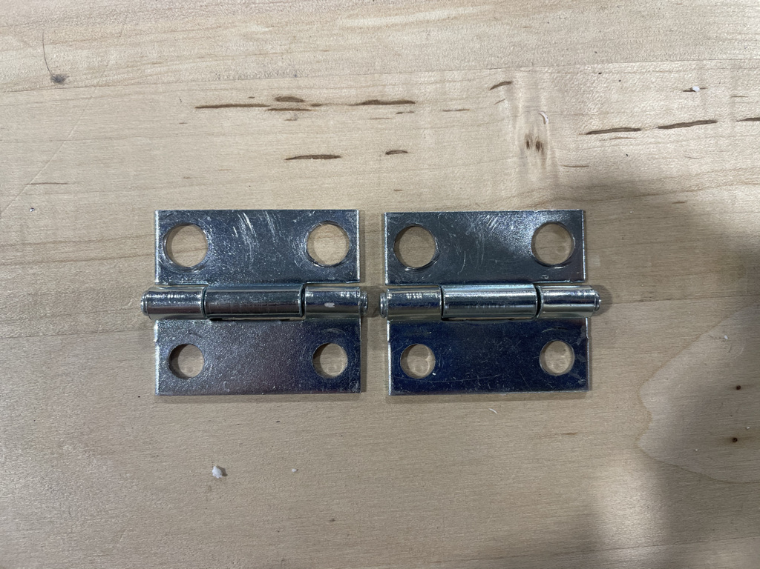

Slide four M6 T-nuts into the front of the 200mm extrusion that was recently removed.

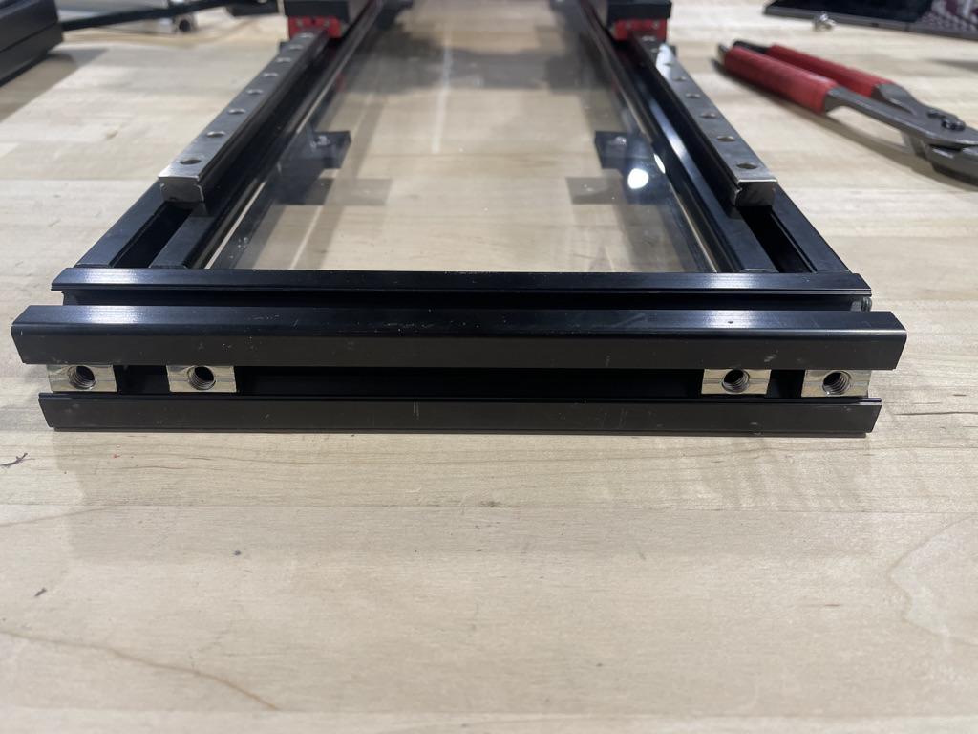

Use M6x10mm screws on the inside T-nuts, on the drilled holes of the hinges. Leave them slightly loose.

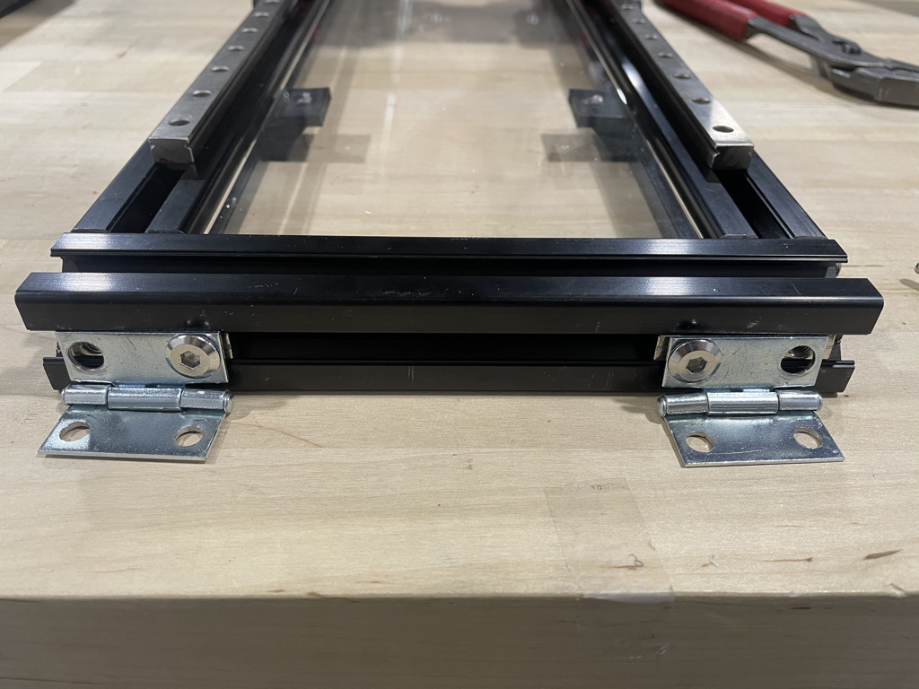

Screw in two M6x12mm screws, aligning them so they go into the drilled holes of the extrusions. Tighten the M6x10mm screws as well.

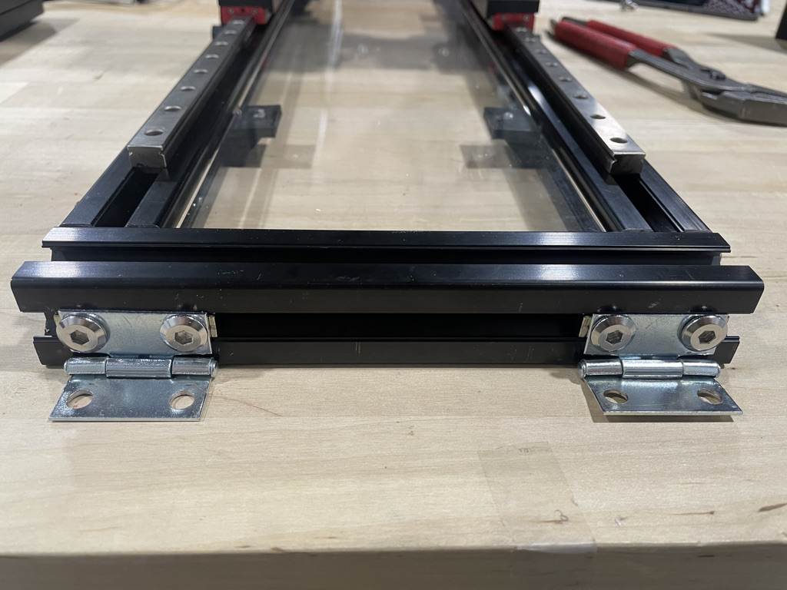

Place the assembly on the large slab of acrylic, lining the edges together.

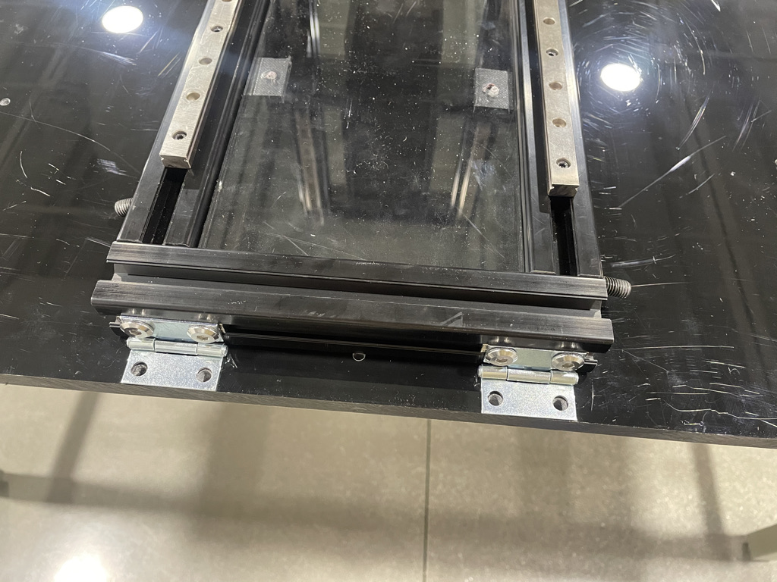

Mark where the holes are, drill and tap them for M6 thread. Then fasten the assembly to the acrylic, careful not to strip the threads.

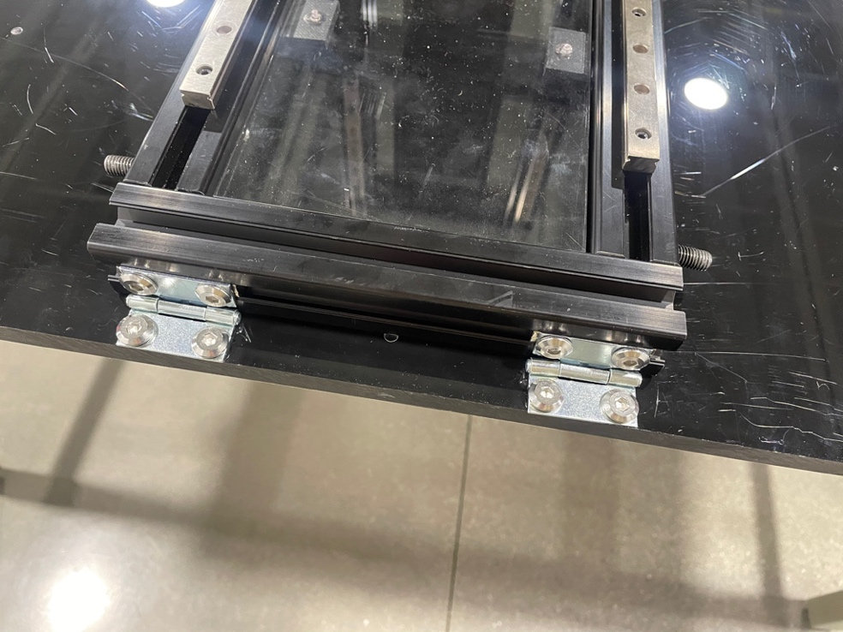

To setup the legs that hold the assembly at a 20-degree angle, prepare both *20_degree_hold_v2* with an M8x40mm socket cap, two *608_washer*, and two 608rs bearings.

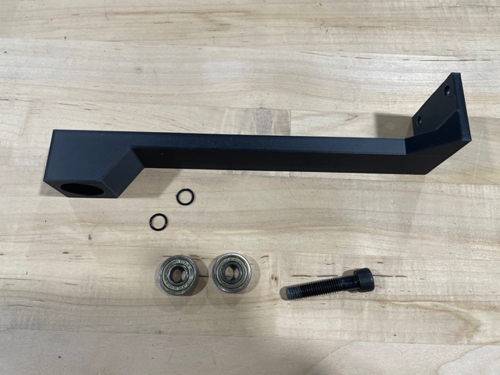 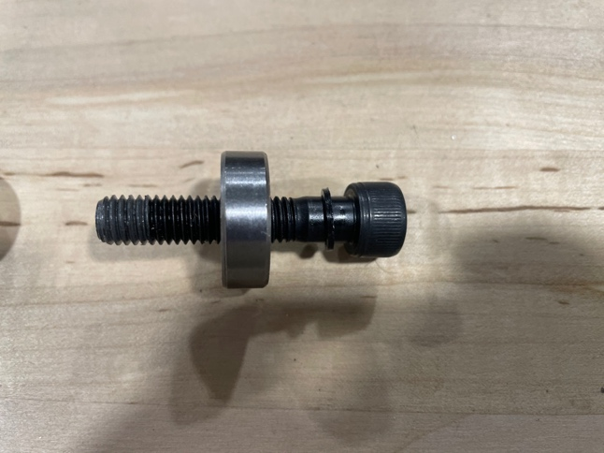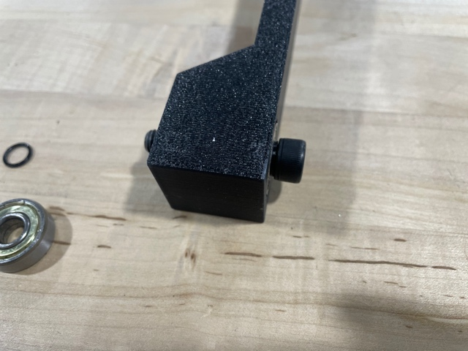 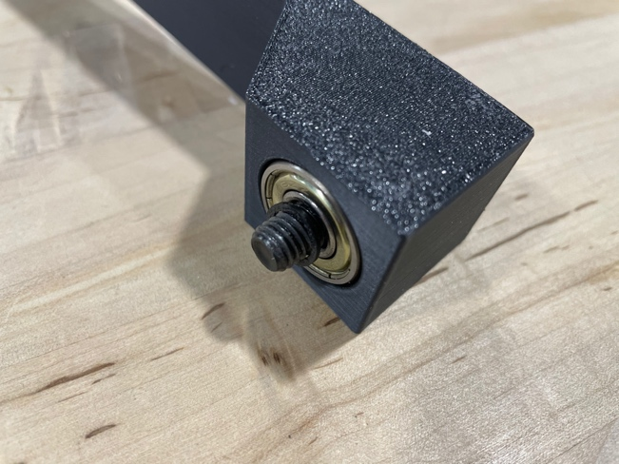

Screw each into the tapped 200mm extrusions so that they’re able to lie flat on the large acrylic sheet.

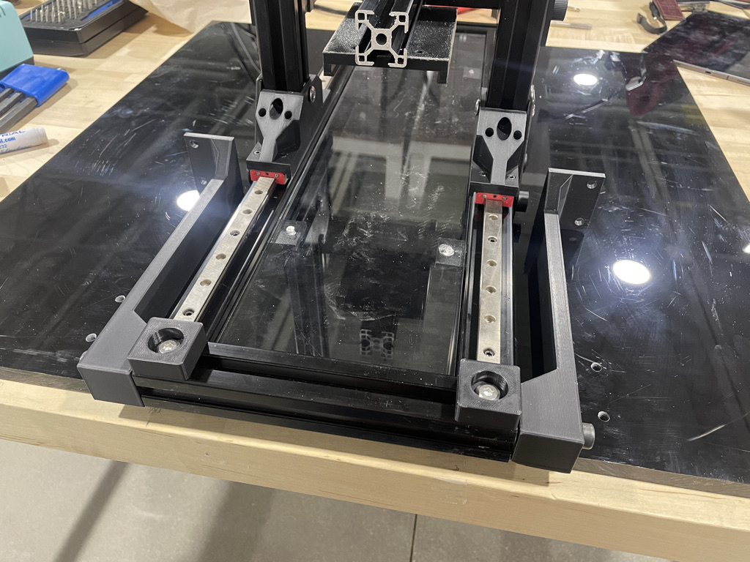

Prop up the legs, marking the holes. Drill and tap them for M6 thread. When propped up, put M6x12mm screws in to hold it.

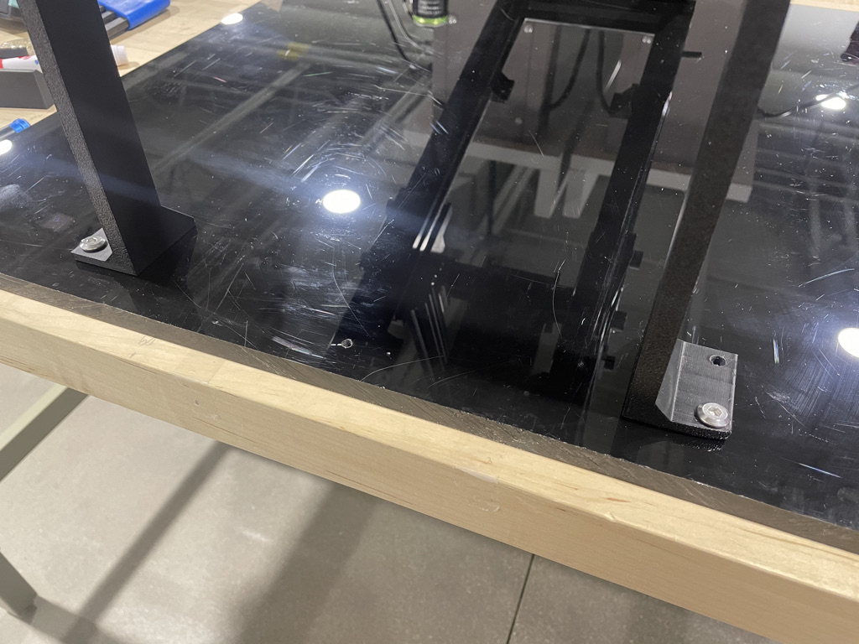

Prepare the *foot_backing* with two M3x12mm socket cap screws and two M3 T-nuts.

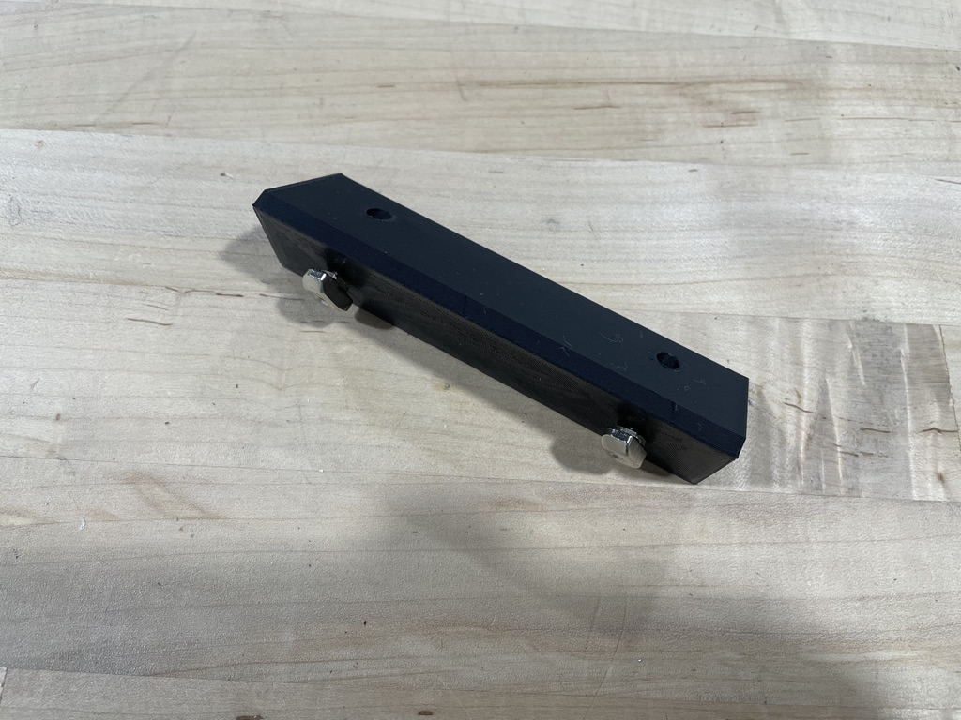

Attach *foot_backing* to the top of the extrusion with the hinges.

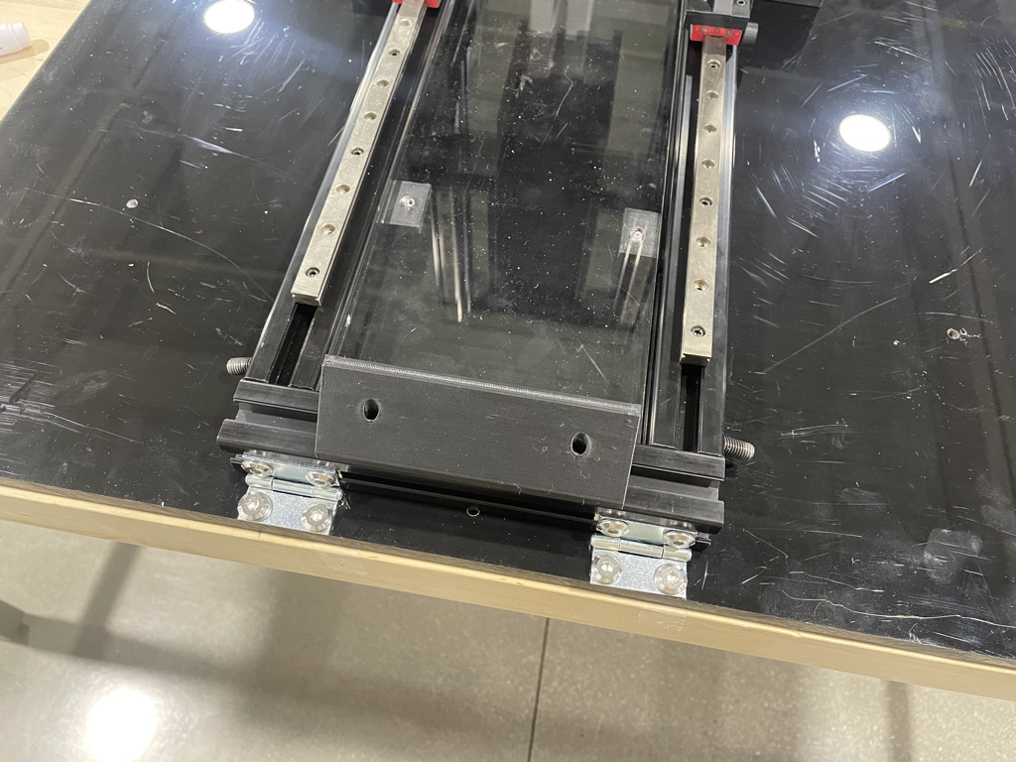

Prepare both 300mm extrusions by drilling and tapping an M8 thread 15mm away from the edge.

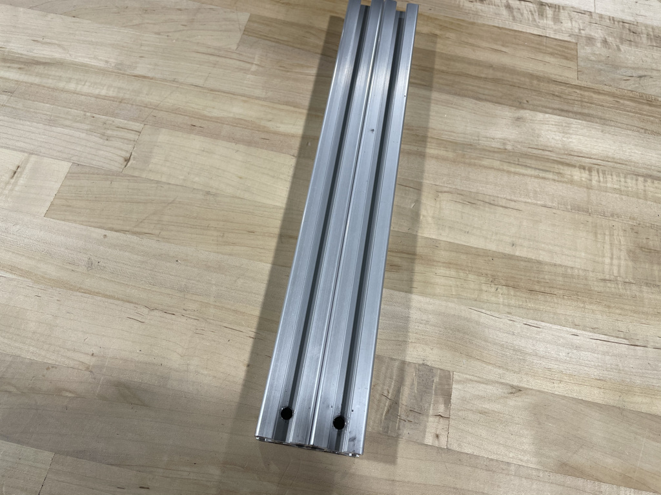

Either prop up the assembly or remove it from the acrylic board. Use the dangling M8x20mm socket cap screws to secure the 300mm extrusions to the side.

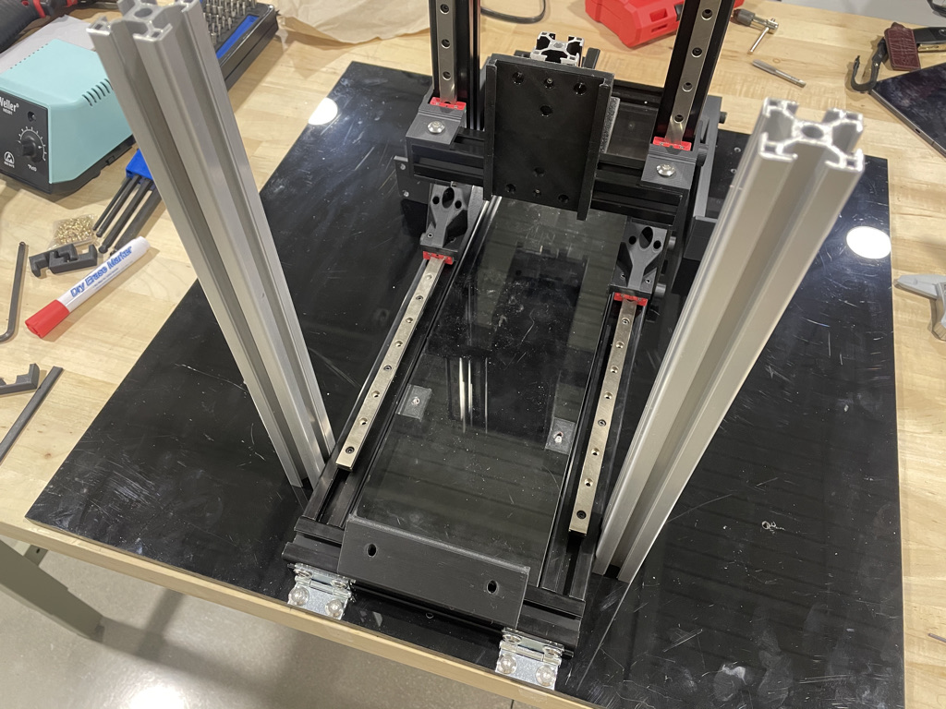

Attach *slide_male_new* to the back of the force transducer with M4x10mm socket cap screws.

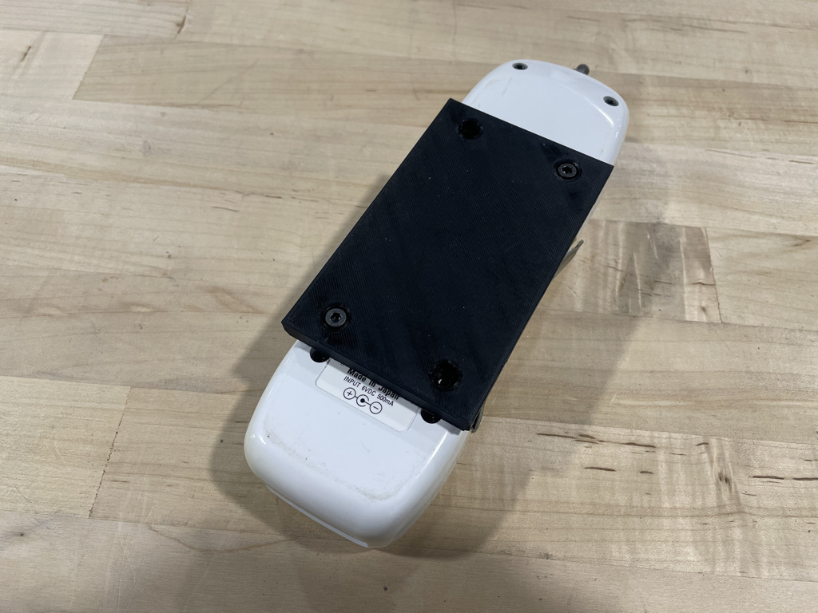

Super glue an M6 nut in the *force_attachment*.

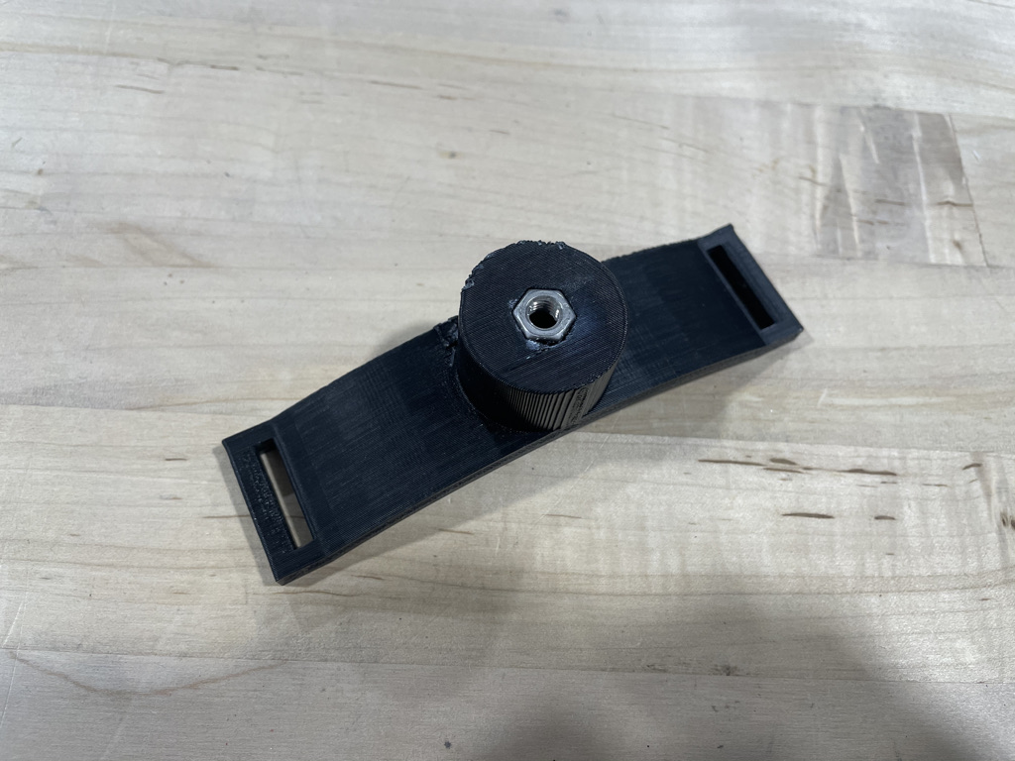

Screw it on the force transducer.

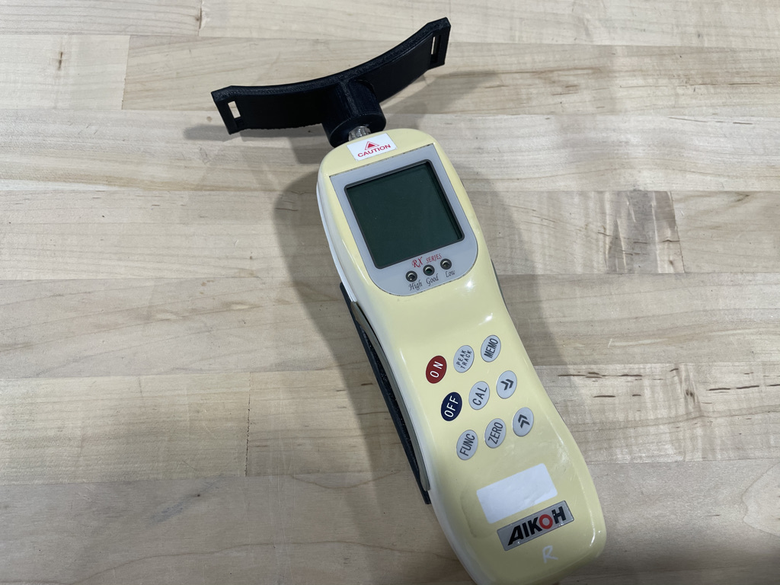

Now, the force transducer can slide into the holder and be held in place with *dowel*.

